**CHAPTER – 1**

**INTRODUCTION**

**1.1 INTRODUCTION**

In today's world, technology is reaching new heights. At first, no one thought of flying in the air or communicating with people thousands of miles away, but in this day and age, anything is possible because technology is developing so fast. The development of technology is proportional to the needs of society. Computers have changed people's lives by making their jobs easier.

India is a developing country at the same time with a lot of increasing crime rates these days. There are many laws in India to prevent and control crime although the crime rate is increasing because the punishments are not enough for the criminals. Punishment must be severe to reduce crime rate. All punishment is based on the same motive of punishing the wrongdoer. There are different types of punishment in India like death penalty, life imprisonment, imprisonment, etc. Crime is a public crime. It is an offensive act, violates the law and is vehemently opposed by society. The scientific study of the nature, extent, causes, and control of criminal behavior in individuals and in society is called criminology. No individual is a born criminal, it is the circumstances and conditions surrounding that individual that make him a criminal. Criminology is the science that studies crime as a social phenomenon. Edwin Sutherland (1947) noted in an early analysis that criminology studies the processes of making laws, breaking laws, and reacting to breaking laws. These processes are three aspects of a somewhat unified series of interactions. Certain behaviors that are considered undesirable are defined by political society as crimes. Despite this definition, some people continue the behavior and thus commit crimes; political society responds with punishment or other treatment or by prevention. This series of interactions is the subject of criminology. Cybercrime, particularly involving the Internet, represents an extension of existing criminal behavior along with a number of new illegal activities. Despite using various modern technologies available, the crime rate has not decreased significantly. It is difficult to predict which criminal will commit a crime, but the location and likelihood of the type of crime can be predicted very well. For modeling purposes, we won't need to delve into criminal justice, but just limit ourselves to the main types of crimes. Cluster (of crime) has a special meaning and refers to a geographical area of ​​crime. These crime clusters can be plotted geospatially on a map with precise location coordinates. It will also help to visually represent densely populated crime areas, or in other words, crime "hotspots". However, when we talk about clustering from a data mining perspective, we are referring to similar types of crimes in a given geographic area of ​​interest. These clusters are useful in identifying a pattern of crime. Complainants will easily report crimes they witness without fear of involving problems due to confidentiality that only authorized users can view reports. It is believed that humans evolved from apes-like ancestors. With the evolution of man has developed his spirit and thinking. Humans began to use raw leaves, insects and animals as food. Later, when he discovered fire, he knew that food tastes better when cooked. He used animal skins to cover his body. He stayed in the cave to protect himself from the harshness of the climatic conditions.

**1.2 KEYWORDS**

Government, Law, Crime, Constitution, Punishments, Police, Criminals, Investigation, Criminal Procedures, Case, Acts, Sections, Illegal

**1.3 OBJECTIVES**

* The main objective is to build an application where the punishment for each and every crime is stated at a single place.
* This application creates awareness about the constitution of India.
* It shows what punishment has to be given to what crime.
* View towards crime, criminals, punishment, and treatment are shaped by local forces. Hence, every person who commits a crime deserves the punishments according to the law.
* This application is user-friendly as the user can easily find the punishment for any crime.

**1.4 STATEMENT OF PROBLEM**

Research on crime and the evolution of the criminal justice system has been extensively published. It was hoped that the court records would open a door to hearing the voices of those whose lives had not previously been well-documented in the standard historical sources. The majority of tasks, including submitting complaints, taking legal action against criminals, viewing status, etc., are completed by hand. Therefore, under the current system, anyone wishing to file a complaint regarding criminal activity must do so through the police.

**1.5 METHODOLOGY**

Our application makes sure the victim or any person who wants to know about the punishments which are to be given to the criminal knows the right punishment. Easily accessible and reliable for the user. Less time consuming in case of emergencies.

**1.6 LIMITATIONS**

* The existing system is time consuming and not very user friendly.
* In most of the cases, the innocent are accused.
* The existing system is criticized for being inefficient, time consuming, poorly managed, and lacking flexibility.
* Because of the large number of serious crimes, minor complaints may be ignored.
* Many of the minor crimes are ignored/the criminals are not punished.

**CHAPTER – 2**

**LITERATURE SURVEY**

**2.1 LITERATURE SURVEY**

|  |  |  |  |  |
| --- | --- | --- | --- | --- |
| **SL NO.** | **TITLE OF THE PAPER** | **AUTHORS** | **JOURNAL YEAR** | **REMARKS** |
| 01. | Crime Rate Prediction Using Machine Learning and Data Mining | Sakib Mahmud, Musfika Nuha, Abdus Sattar | 2022 | Different data mining clustering methods are used to analyse the crime rate of Bangladesh and we also use K-nearest neighbor (KNN) algorithm to train our dataset. By analysing the data, we find out the predictive rates of different crimes in various places and use an algorithm to determine the path prediction rates. This system will help individuals to be aware of the crime zone and discover their safe path to the destination. |
| 02. | Crime Type and Occurrence Prediction using Machine Learning Algorithm | N Kanimozhi,  N V Keerthana, G S Pavithra,  G Ranjitha,  S Yuvarani | 2021 | It mandates crime pattern analysis using open-source Kaggle crime data, which is then used to predict the crimes that happen the most frequently. a calculation of the amount of each type of crime, along with the date and place when it occurred. This work uses machine learning algorithms like Naive Bayes to classify different crime patterns, and the accuracy achieved was relatively high when compared to pre-composed works. |
| 03. | Crime Prediction and Analysis | Pratibha Kumari,  Akanksha Gahalot,  Uprant,  Suraina Dhiman,  Lokesh Chouhan | 2020 | The ability to predict and analyse crime is crucial for preventing and detecting future crimes. The efficient and accurate analysis of the increasing amount of crime data is a major challenge for law enforcement organizations. Without any computational support, it is challenging for crime analysts to analyze such vast amounts of crime data. The main goal is to demonstrate the value and potency of machine learning in predicting violent crimes occurring in a specific area so that police can use it to lower crime rates in society. |
| 04. | Cybercrime Regulation Through Laws and Strategies: A Glimpse into the Indian Experience | Annappa Nagaratha | 2020 | Give a general overview of the strategy used in India, focusing on the legal strategy used to combat cybercrime. The Indian Penal Code and other traditional criminal laws contain a number of legal provisions that could be used to regulate cybercrimes, but due to the evolving nature of these crimes, a new legal framework was required. The need to constantly review and revise a country's strategies arises from the fact that cybercrimes are technical and dynamic in nature. |
| 05. | Crime Prediction and Analysis System | Peiris M.D.P.T , Shaminda M.B.D, Senarathne H.K, Dr.Gayana Fernando | 2020 | The analysis and recording of crime data have become more challenging due to the vast geographic diversity and complexity of crime patterns. The implemented system is a remedy to be applied in sophisticated crime analysis and prediction systems that are intended to address the crime issues. |
| 06. | Development of an Online Crime Management and Reporting System | Tomas Ucol Ganiron Jr., John Stephen Chen, Ronalyn Dela Cruz, Jeromme G. Pelacio | 2019 | identifies methods for the investigation and detection of the volume of crimes that are effective and efficient. aims to draw attention to the investigative techniques and actions that have the best chance of producing positive results. aids in facilitating easy and private communication between the authority and the complainant regarding the reported issue. The following areas warrant more research, according to the researchers: expanding the system's reach by taking other cities into account; developing a general platform for maintaining human records from conception to death; and implementing World Scientific News |
| 07. | Crime Prediction System | Pankaj Kushwaha,  Kiran Kunwar,  Archna Verma,  Simili Shetty,  Sampada Watane | 2019 | This essay considers Malaysia as a particular location. Using a technique called univariate forecasting, the system locates crime trends in Kedah. For security forces to make the best use of their human and technological resources, it is crucial to identify potential suspects in advance. This process also plays a key role in crime prediction. Despite the fact that we are unable to predict the outcome with absolute certainty, the application does so by giving the user more chances to try. |
| 08. | A Law Enforcement Information Management System | Alvin Chesaro | 2018 | Through automated processes, this records management system enables efficient and trustworthy records management and provides a framework for analysis. The project's scope was the biggest drawback, according to a thorough evaluation, even though it met many of its predetermined goals. The system created is an effective, usable, and trustworthy records management system as a result of a thorough analysis and evaluation of the designed system. |
| 09. | Crime Rate Prediction Using Data Clustering Algorithms | Omkar Vaidya, Sayak Mitra, Raj Kumbhar, Suraj Chavan, Rohini Patil | 2018 | Data mining techniques and data clustering algorithms can be used to extract unknown but valuable information from unstructured data. tracks criminal activity and aids the criminal justice system in more quickly solving crimes. The most recent police data is used, which, after being subjected to a variety of clustering and prediction algorithms, yields information that can be used to predict the likelihood of incidents, monitor criminal activity, and assist law enforcement agencies in allocating resources and resolving criminal cases more quickly. |
| 10. | Crime Pattern Detection, Analysis and Prediction | Sunil Yadav, Meet Timbadia, Ajit Yadav, Rohit Vishwakarma, Nikhilesh Yadav | 2017 | The system is fed with crime data from prior years that was obtained from a reliable Indian online portal. used semi-supervised, supervised, and unsupervised learning techniques on the crime records to aid in improving the crime's prognostication accuracy, which aids the neighborhood police stations in crime prevention. For knowledge discovery and to aid in boosting the crime's predictive accuracy, we have applied supervised, semi-supervised, and unsupervised learning techniques to the crime records. |

**2.2 FEASIBILITY STUDY**

A system proposal is put to the test in a feasibility study for its viability, impact on the organization, ability to meet user needs, and efficient use of resources. The goal of a feasibility study is to understand the scope of the issue rather than to solve it. Costs and benefits are estimated in greater detail at this stage due to the study's crystallization of the problem definition and determination of the aspects of the problem to be included in the system. A formal system proposal is the outcome of the feasibility study. This is merely a method of describing in detail the type and extent of solutions that have been suggested. What is known and what will be done are outlined in the proposal. The three most important factors that go into Feasibility study are:

* Economic feasibility
* Technical feasibility
* Behavioral feasibility

**2.2.1 ECONOMIC FEASIBILITY**

* Comparing the cost to the benefit or income that is anticipated from a developed system using economic analysis is one of the most popular methods.
* While there are many participants in the process under the current system, there are fewer in the system under consideration. As a result, the suggested system is practical.

**2.2.2 TECHNICAL FEASIBILITY**

* The existing computer system's (software, hardware) ability to support the proposed addition is at the heart of the feasibility analysis.
* The database management system software in the proposed system makes it simple to store and manage data.
* It is simple to generate search results. The system can therefore be implemented technically.

**2.2.3 BEHAVIORAL FEASIBILITY**

* Change is difficult for people to accept, despite the fact that computers have been shown to make it easier. It is important to make an educated guess as to the likely intensity of the user staff's response to computer system developments.
* While more manpower and time are needed in the current system, these requirements are decreased in the proposed system. As a result, those who are still around are working on other crucial projects.

**CHAPTER – 3**

**HARDWARE AND SOFTWARE REQUIREMENTS**

**3.1 HARDWARE REQUIREMENTS**

|  |  |
| --- | --- |
| Processor | Intel Pentium III or latest |
| RAM | 4 GB |
| Hard disk | 10 GB |
| Cache Memory | 512 KB |

**3.2 SOFTWARE REQUIREMENTS**

|  |  |
| --- | --- |
| Front End | Microsoft Visual Studio 2010 |
| Back End | Microsoft SQL Server Database |
| Operating System | Windows 7,8,9,10,XP |

**CHAPTER – 4**

**SYSTEM REQUIREMENT SPECIFICATIONS**

* **ADMIN**

In the admin module, the administrator can login to the application. Only the administrator has access to login credentials. He also has access to all the database of the application.

* **USER**

In the user module, the user can search the crime, they’ll get the details of the crime and also the punishments with IPC sections of the corresponding crime. The user can take the print of the report.

**CHAPTER – 5**

**DESIGN AND IMPLEMENTATION**

**5.1 DESIGN**

**5.1.1 DATA FLOW DIAGRAM**

**DATA FLOW DIAGRAM LEVEL-0**

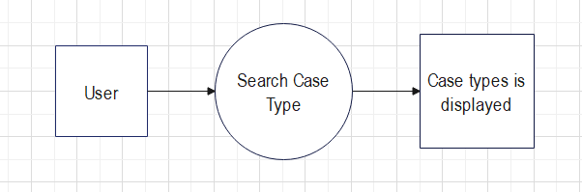

**DATA FLOW DIAGRAM LEVEL-1**

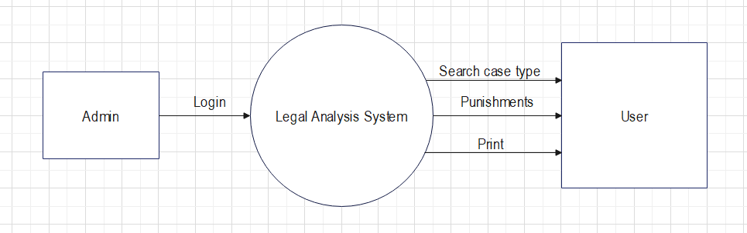

**5.1.2 USE CASE DIAGRAM**

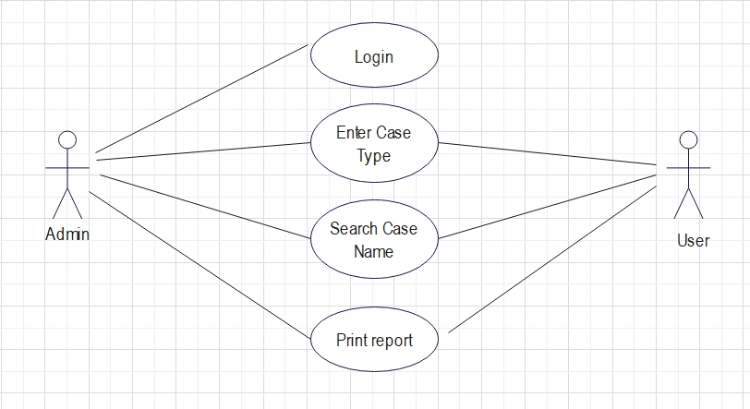

**5.1.3 SEQUENCE DIAGRAM**

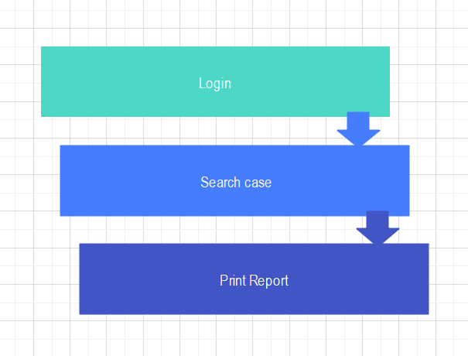

**5.1.4 ER DIAGRAM**

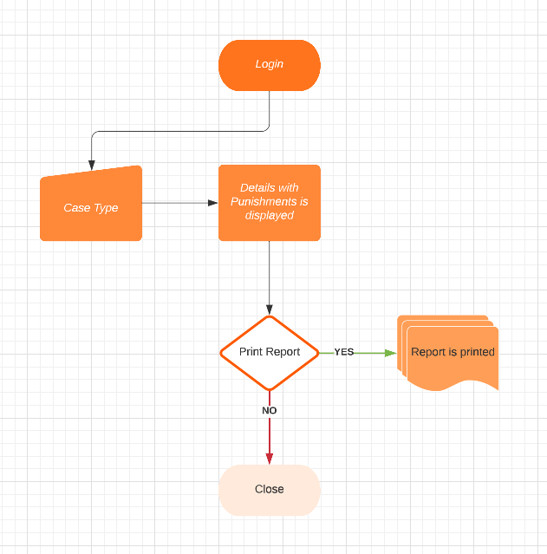

**5.2 FORM DESIGN**

**5.2.1 FORM 1**

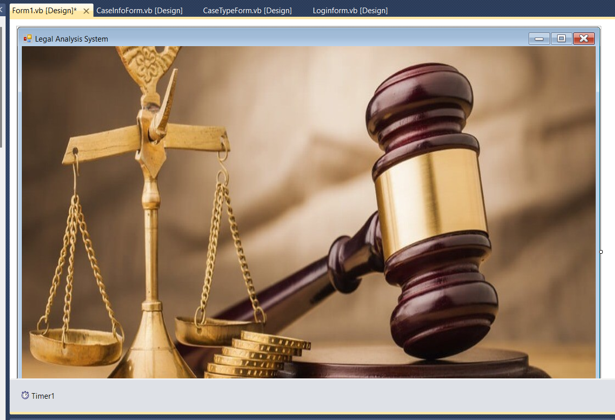

**5.2.2 LOGIN FORM**

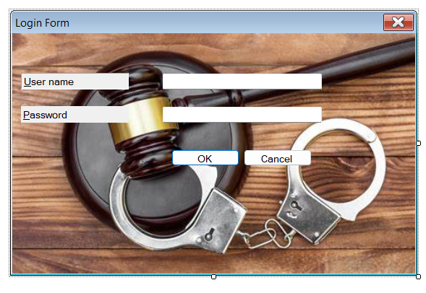

**5.2.3 MDI PARENT FORM**

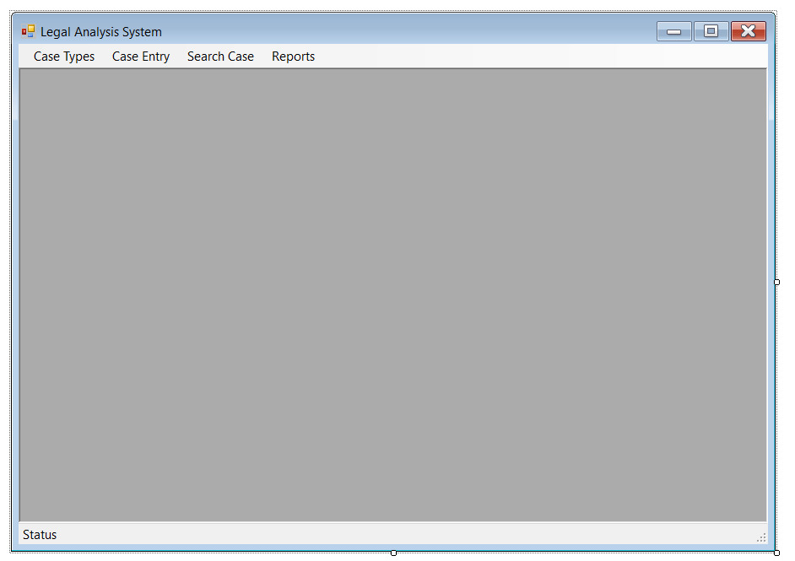

**5.2.4 CASE TYPE FORM**

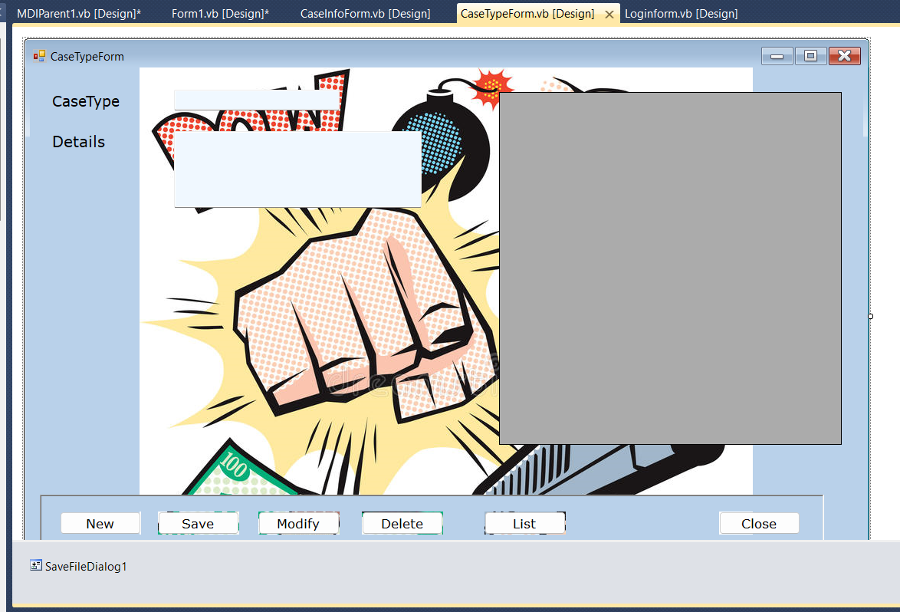

**5.2.5 CASE INFO FORM**

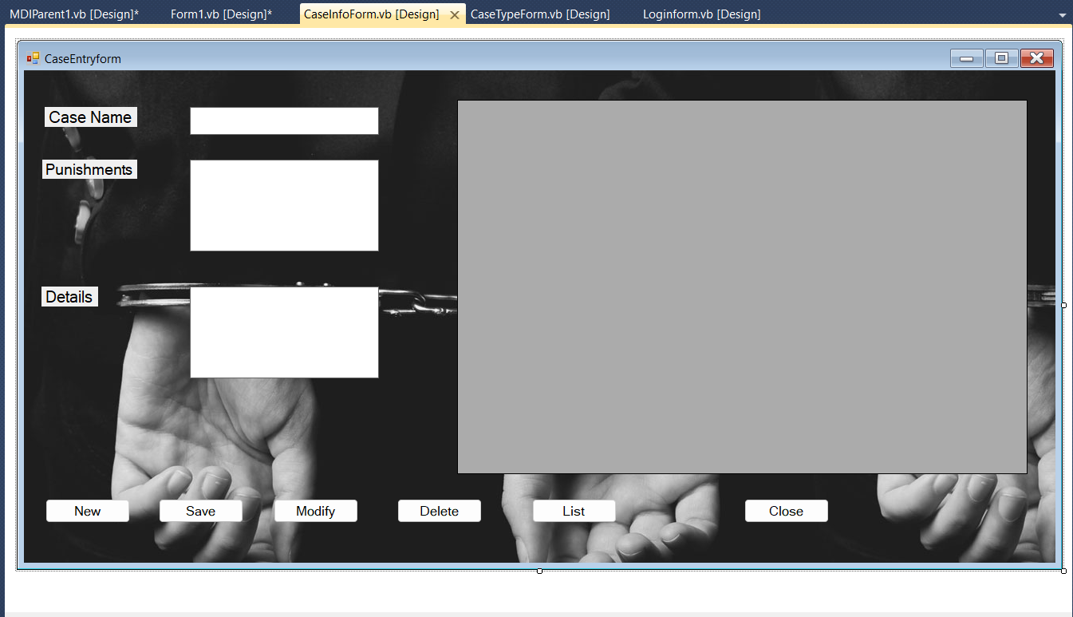

**5.2.6 SEARCH FORM**

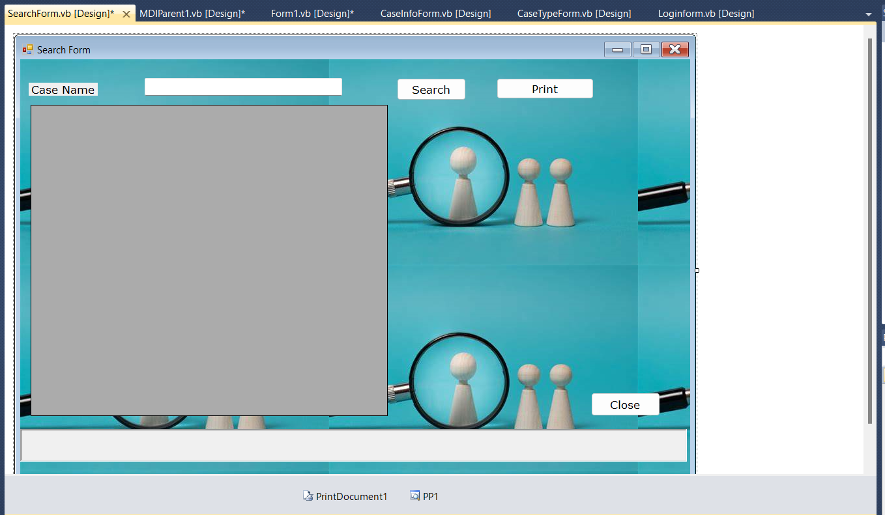

**5.2.7 REPORTS FORM**

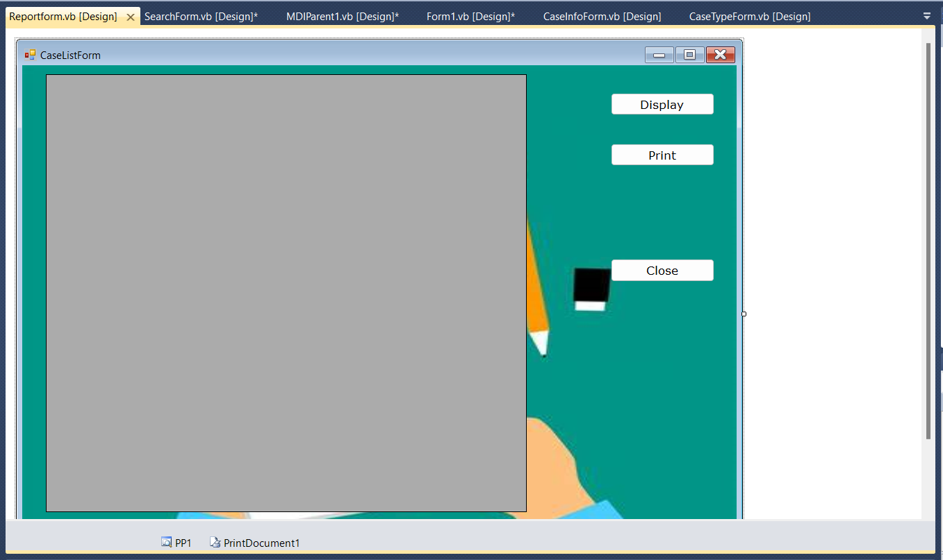

**5.3 TABLE SCHEMA**

**5.3.1 LOGIN FORM**

|  |  |
| --- | --- |
| **COLUMN NAME** | **DATA TYPE** |
| Username | nvarchar(50) |
| Password | nvarchar(50) |

**5.3.2 CASE TYPE FORM**

|  |  |
| --- | --- |
| **COLUMN NAME** | **DATA TYPE** |
| CaseType | nvarchar(50) |
| Details | nvarchar(50) |

**5.3.3 CASE INFO FORM**

|  |  |
| --- | --- |
| **COLUMN NAME** | **DATA TYPE** |
| CaseName | nvarchar(50) |
| Punishment | nvarchar(100) |
| CaseType | nvarchar(50) |

**5.3.4 SEARCH FORM**

|  |  |
| --- | --- |
| **COLUMN NAME** | **DATA TYPE** |
| CaseName | nvarchar(50) |
| Punishment | nvarchar(200) |

**5.4 DATABASE**

**5.4.1 LOGIN FORM**

|  |  |
| --- | --- |
| **Username** | **Password** |
| admin | admin |
| Nidhi | Nidhi1234 |
| Anusha | Anusha9876 |
| Legal | analysis |
| NULL | NULL |

**5.4.2 CASE TYPE FORM**

|  |  |
| --- | --- |
| Abduction | Kidnapping (taking someone against their will) |
| Arson | Setting fire to a property |
| Assault | A physical attack |
| Burglary | Entering a building to commit a crime |
| Blackmailing | Force to do something using threats. |
| Child abuse | Maltreatment of a child |
| Drug trafficking | Importing illegal drugs |
| False imprisonment | Imprisoning a person without legal authority |
| Fraud | Deception for a personal or financial gain |
| Hacking | Unauthorized access to data |
| Hijacking | illegally getting control an aircraft or vehicle |
| Human trafficking | Illegally transporting people |
| Premediated murder | Murder that is intentional |
| Unpremeditated murder | Unintentional murder |
| Manslaughter | Murder that is not intentional |
| Attempted murder | Planning to kill another person |
| Patricide | Killing one’s own father |
| Genocide | Systematic killing of a religious group |
| Euthanasia | Killing for one’s own benefit |
| Organised Crime | Crime by an Organization |
| Smuggling | Illegal import and export |
| Terrorism | Unlawful violence with political aims |
| White collar crime | Financially motivated crime by a worker |
| Pickpocketing | Taking from another person’s pocket |
| Shoplifting | Taking products from a shop without paying for it |
| Extermination | Killing a group of people |
| Drunk driving | Driving with alcohol consumption |
| Jay walking | Crossing road at an undesignated spot |
| Running a red light | Going through red traffic lights |
| Speeding | Crossing speed limit |
| Vandalism | Destructing a building |
| Discrimination | Unjust treatment |
| Peer pressure | Pressure from friends or colleagues |
| Forgery | Imitation of a document |
| Enslavement | Forcible transfer of population |
| Torture | Inflict severe pain or suffering on |
| Sexual violence | Sexual act by violence or coercion |
| Email Frauds | Intention of deception by means of mail |
| Social media frauds | Fraud committed on social networking sites |
| Banking frauds | Stolen debit or credit cards |
| Acid attack | violent assault of throwing acid |
| Cyber Espionage | Gain illicit access to confidential info |
| Identity theft | Using another person’s info for official purposes |
| Mugging | Attacking a person in public |
| Aggravated Assault | Physically attacking another person |
| Bribery | The giving or offering of a bribe |
| Cyber Bullying | Harassing others online |
| Cyber Stalking | Stalking other person online |
| Cyber Grooming | Pressurizing a teenager for online sexual act |
| Murder | Death penalty |
| Phishing | Sending malicious attachment through email. |
| Robbery | Taking property unlawfully from a person or place |
| Rape | Sexual intercourse w/o a persons consent |
| Hit and run | an accident in which the vehicle does not stop |
| Rash driving | driving carelessly about people or property |
| Dowry | payment by bride fam to groom fam in marriage |
| NULL | NULL |

**5.4.3 CASE INFO FORM**

|  |  |  |
| --- | --- | --- |
| Murder | Section 302: Death penalty, Lifetime Imprisonment or fine | Death penalty |
| Robbery | Section 392: Up to 10yrs of imprisonment and fine. | Taking property unlawfully from a person or place |
| Abduction | Section 363: Simple imprisonment or Rigorous imprisonment extendable up to 7 years and Fine. | Kidnapping (taking someone against their will) |
| Acid Attack | Section 326A: Min 10years of imprisonment with fine. | violent assault of throwing acid |
| Aggravated Assault | Section 352: Imprisonment of which may extend to 3 months, or with fine of rupees 500, or both. | Physically attacking another person |
| Arson | Section 436: Imprisonment for lifetime or for 10years with fine | Setting fire to a property |
| Attempted Murder | Section 307: imprisonment for 10years with fine | Planning to kill another person |
| Banking Fraud | Section 405: Imprisonment of upto 3 years or fine or both | Stolen debit or credit cards |
| Bribery | Section 171E: Imprisonment of one year or fine or both | The giving or offering of a bribe |
| Burglary | Section 392: Imprisonment of up to 3years or fine or rigorous imprisonment of 10years with fine. | Entering a building to commit a crime |
| Cyber Bullying | Section 354D: 1-3 years of imprisonment for 1st time and 3-7 years for second-time offenders | Harassing others online |
| Cyber Espionage | Section 419 and 420: imprisonment of 3-7 years  or fine | Gain illicit access to confidential info |
| Phishing | Section 419: The punishments are different based upon the gravity of the committed cybercrime | Sending malicious attachment through email. |
| Cyber Grooming | Section 354D: 1-3 yrs of imprisonment for 1st time n 3-7 yrs for 2nd time offenders. | Pressurizing a teenager for online sexual act |
| Discrimination | Section 153C: 3years or fine or both | Unjust treatment |
| Drug Trafficking | Section 276: imprisonment of up to 10-20years and fine of 10-20lakhs. | Importing illegal drugs |
| Drunk Driving | Section 304A: 1st time- Rs10k fine n 6 mths jail,2nd time- Rs15k fine n 2years jail | Driving with alcohol consumption |
| Enslavement | Section 371: Imprisonment | Forcible transfer of population |
| Euthanasia | Section 306: imprisonment of upto ten years, and shall also be liable to fine. | Killing for ones own benefit |
| False Imprisonment | Section 193:  imprisonment for 7yrs and shall also be liable to fine | Imprisoning a person without legal authority |
| Forgery | Section 465: Imprisonment of 2yrs or fine or both | Imitation of a document |
| Genocide | Section 1860: Imprisonment for upto 20years or fine or both | Systematic killing of a religious group |
| Hacking | Section 66: imprisonment up to 3 years, or a fine up to 2 lakh rupees, or both | Unauthorized access to data |
| Human Trafficking | Section 370: Imprisonment of 7-10years or fine | Illegally transporting people |
| Identity Theft | Section 411: Imprisonment upto 3years and fine upto Rs.1lakh | Using another persons info for offical purposes |
| Mugging | Section 394: imprisonment for upto 10 years and fine. | Attacking a person in public |
| Organised Crime | Section 120B: Issuing verbal warnings | Crime by an Organization |
| Peer Pressure | Section 425: Imprisonment or fine or both | Pressure from friends or colleagues |
| Premediated murder | Section 302: Death penalty, Lifetime Imprisonment or fine | Murder that is intentional |
| Running a red light | Section 279: Imprisonment upto 6months or Rs.1000 fine or both | Going through red traffic lights |
| Shoplifting | Section 379: Imprisonment upto 3years or finr or both. | Taking products from a shop without paying for it |
| Social media frauds | Section 66B: imprisonment upto 3yrs or fine upto Rs 1lakh. | Fraud committed on social networking sites |
| Speeding | Section 279: Imprisonment upto 6months or fine upto Rs 1000 or both | Crossing speed limit |
| Theft | Section 379A: Upto 3yrs of imprisonment or fine or both | Stealing something |
| Torture | Section 360: 3-7 years of imprisonment if proven guilty. | Inflict severe pain or suffering on |
| Unpremeditated murder | Section 302: Imprisonment for life or death penalty or fine. | Unintentional murder |
| Vandalism | Section 427: imprisonment upto 2years or fine or both. | Destructing a building |
| White collar crime | Section 447: Imprisonment of less than 6months upto 10years | Financially motivated crime by a worker |
| Blackmailing | Section 384: Imprisonment of 3years or fine or both | Force to do something using threats. |
| Child Abuse | Section 75: Imprisonment of 3years upto 10years with fine upto 5lakh rupees. | Maltreatment of a child |
| Cyber Stalking | Section 354D: imprisonment up to 3 years and a fine. | Stalking other person online |
| Email Frauds | Section 463: Imprisonment of more than 3years or fine exceeding Rs.5L | Intention of deception by means of mail |
| Extermination | Section 506: Death penalty, fine or imprisonment for life. | Killing a group of people |
| Fraud | Section 420: Imprisonment upto 2yrs or fine or both | Deception for a personal or financial gain |
| Hijacking | Section 3: Imprisonment for life or fine | illegally getting control an aircraft or vehicle |
| Jay Walking | Section 452:  the trespasser is punishable with a min sentence of 7 yrs with fine. | Crossing road at an undesignated spot |
| Patricide | Section 306: 10yrs of imprisonment and fine | Killing ones own father |
| Pickpocketing | Section 379: 7 to 10yrs imprisonment with upto Rs.25k fine | Taking from another persons pocket |
| Sexual Violence | Section 376: Imprisonment of 7-10yrs  or fine or both | Sexual act by violence or coercion |
| Smuggling | Imprisonment of 2 to 5years | Illegal import and export |
| Terrorism | Section 260/262: Imprisonment upto 3yrs or fine or both | Unlawful violence with political aims |
| Rape | Section 376: Imprisonment of 10years or more or fine or both | Sexual intercourse w/o a persons consent |
| Hit and run | Section 279, 304A, 338:  Imprisonment for 6 months, a fine of Rs1000 | an accident in which the vehicle does not stop |
| Rash driving | Section 279: imprisonment for 6months or fine | driving carelessly about people or property |
| Dowry | Section 498A: Imprisonment for 5 years and Rs.15,000 fine | Payment by bride fam to groom fam in marriage |
| NULL | NULL | NULL |

**5.5 IMPLEMENTATION(CODING)**

**5.5.1 FORM 1**

Public Class Form1

Dim I As Integer

Private Sub Timer1_Tick(ByVal sender As System.Object, ByVal e As System.EventArgs) Handles Timer1.Tick

I = I + 1

If I = 5 Then

Me.Hide()

Loginform.Show()

Me.Hide()

End If

End Sub

Private Sub Form1_Load(sender As System.Object, e As System.EventArgs) Handles MyBase.Load

Me.WindowState = FormWindowState.Maximized

End Sub

End Class

**5.5.2 LOGIN FORM**

Imports System.Data.SqlClient

Imports System.Text.RegularExpressions

Public Class Loginform

' TODO: Insert code to perform custom authentication using the provided username and password

' (See http://go.microsoft.com/fwlink/?LinkId=35339).

' The custom principal can then be attached to the current thread's principal as follows:

' My.User.CurrentPrincipal = CustomPrincipal

' where CustomPrincipal is the IPrincipal implementation used to perform authentication.

' Subsequently, My.User will return identity information encapsulated in the CustomPrincipal object

' such as the username, display name, etc.

Private Sub OK_Click(ByVal sender As System.Object, ByVal e As System.EventArgs) Handles OK.Click

If conn.State = ConnectionState.Open Then conn.Close()

conn.Open()

Dim cmd0 As New SqlCommand("select * from login where Username='" & UsernameTextBox.Text & "' and Password='" & PasswordTextBox.Text & "'", conn)

Dim D1 As SqlDataReader = cmd0.ExecuteReader()

If D1.HasRows Then

MsgBox("Login Success")

MDIParent1.Show()

Else

MsgBox("invalid user")

End If

If conn.State = ConnectionState.Open Then conn.Close()

End Sub

Private Sub Cancel_Click(ByVal sender As System.Object, ByVal e As System.EventArgs) Handles Cancel.Click

Me.Close()

End Sub

Private Sub UsernameTextBox_LostFocus(ByVal sender As Object, ByVal e As System.EventArgs) Handles UsernameTextBox.LostFocus

If Not Regex.Match(UsernameTextBox.Text, "^[a-z. ]*$", RegexOptions.IgnoreCase).Success Then

MsgBox("Please enter alphabets only!")

UsernameTextBox.Focus()

UsernameTextBox.Clear()

End If

End Sub

Private Sub UsernameTextBox_TextChanged(ByVal sender As System.Object, ByVal e As System.EventArgs) Handles UsernameTextBox.TextChanged

End Sub

End Class

**5.5.3 MDI PARENT FORM**

Imports System.Windows.Forms

Public Class MDIParent1

Private Sub ShowNewForm(ByVal sender As Object, ByVal e As EventArgs)

' Create a new instance of the child form.

Dim ChildForm As New System.Windows.Forms.Form

' Make it a child of this MDI form before showing it.

ChildForm.MdiParent = Me

m_ChildFormNumber += 1

ChildForm.Text = "Window " & m_ChildFormNumber

ChildForm.Show()

End Sub

Private Sub OpenFile(ByVal sender As Object, ByVal e As EventArgs)

Dim OpenFileDialog As New OpenFileDialog

OpenFileDialog.InitialDirectory = My.Computer.FileSystem.SpecialDirectories.MyDocuments

OpenFileDialog.Filter = "Text Files (*.txt)|*.txt|All Files (*.*)|*.*"

If (OpenFileDialog.ShowDialog(Me) = System.Windows.Forms.DialogResult.OK) Then

Dim FileName As String = OpenFileDialog.FileName

' TODO: Add code here to open the file.

End If

End Sub

Private Sub SaveAsToolStripMenuItem_Click(ByVal sender As Object, ByVal e As EventArgs)

Dim SaveFileDialog As New SaveFileDialog

SaveFileDialog.InitialDirectory = My.Computer.FileSystem.SpecialDirectories.MyDocuments

SaveFileDialog.Filter = "Text Files (*.txt)|*.txt|All Files (*.*)|*.*"

If (SaveFileDialog.ShowDialog(Me) = System.Windows.Forms.DialogResult.OK) Then

Dim FileName As String = SaveFileDialog.FileName

' TODO: Add code here to save the current contents of the form to a file.

End If

End Sub

Private Sub ExitToolsStripMenuItem_Click(ByVal sender As Object, ByVal e As EventArgs)

Me.Close()

End Sub

Private Sub CutToolStripMenuItem_Click(ByVal sender As Object, ByVal e As EventArgs)

' Use My.Computer.Clipboard to insert the selected text or images into the clipboard

End Sub

Private Sub CopyToolStripMenuItem_Click(ByVal sender As Object, ByVal e As EventArgs)

' Use My.Computer.Clipboard to insert the selected text or images into the clipboard

End Sub

Private Sub PasteToolStripMenuItem_Click(ByVal sender As Object, ByVal e As EventArgs)

'Use My.Computer.Clipboard.GetText() or My.Computer.Clipboard.GetData to retrieve information from the clipboard.

End Sub

Private Sub CascadeToolStripMenuItem_Click(ByVal sender As Object, ByVal e As EventArgs)

Me.LayoutMdi(MdiLayout.Cascade)

End Sub

Private Sub TileVerticalToolStripMenuItem_Click(ByVal sender As Object, ByVal e As EventArgs)

Me.LayoutMdi(MdiLayout.TileVertical)

End Sub

Private Sub TileHorizontalToolStripMenuItem_Click(ByVal sender As Object, ByVal e As EventArgs)

Me.LayoutMdi(MdiLayout.TileHorizontal)

End Sub

Private Sub ArrangeIconsToolStripMenuItem_Click(ByVal sender As Object, ByVal e As EventArgs)

Me.LayoutMdi(MdiLayout.ArrangeIcons)

End Sub

Private Sub CloseAllToolStripMenuItem_Click(ByVal sender As Object, ByVal e As EventArgs)

' Close all child forms of the parent.

For Each ChildForm As Form In Me.MdiChildren

ChildForm.Close()

Next

End Sub

Private m_ChildFormNumber As Integer

Private Sub MDIParent1_Load(ByVal sender As System.Object, ByVal e As System.EventArgs) Handles MyBase.Load

Me.WindowState = FormWindowState.Maximized

End Sub

Private Sub AdminEntriesToolStripMenuItem_Click(ByVal sender As System.Object, ByVal e As System.EventArgs) Handles AdminEntriesToolStripMenuItem.Click

CaseTypeForm.MdiParent = Me

CaseTypeForm.Show()

End Sub

Private Sub SearchCaseToolStripMenuItem_Click(ByVal sender As System.Object, ByVal e As System.EventArgs) Handles SearchCaseToolStripMenuItem.Click

CaseInfoForm.MdiParent = Me

CaseInfoForm.Show()

End Sub

Private Sub ReportsToolStripMenuItem_Click(ByVal sender As System.Object, ByVal e As System.EventArgs) Handles ReportsToolStripMenuItem.Click

SearchForm.MdiParent = Me

SearchForm.Show()

End Sub

Private Sub CaseEntryToolStripMenuItem_Click(ByVal sender As System.Object, ByVal e As System.EventArgs) Handles CaseEntryToolStripMenuItem.Click

Reportform.MdiParent = Me

Reportform.Show()

End Sub

End Class

**5.5.4 CASE TYPE FORM**

Imports System.Data.SqlClient

Public Class CaseTypeForm

Dim pkVar As String

Private Sub VehicleForm_Load(ByVal sender As Object, ByVal e As System.EventArgs) Handles Me.Load

Me.WindowState = FormWindowState.Maximized

disRecords()

End Sub

Private Sub butSave_Click(ByVal sender As System.Object, ByVal e As System.EventArgs) Handles butSave.Click

SaveRecord()

butNew.Enabled = True

butSave.Enabled = True

butModify.Enabled = True

ButDelete.Enabled = True

End Sub

Sub SaveRecord()

If TextBox1.Text = "" Then

MsgBox("Please enter the case type")

Exit Sub

End If

If TextBox2.Text = "" Then

MsgBox("Please enter the details")

Exit Sub

End If

If Conn.State = ConnectionState.Open Then Conn.Close()

Conn.Open()

Dim Cmd0 As New SqlCommand("select * from CaseTypeTab where CaseType='" & TextBox1.Text & "'", conn)

Dim D1 As SqlDataReader = Cmd0.ExecuteReader()

If D1.HasRows Then

MsgBox("This record is already present in the database")

If Conn.State = ConnectionState.Open Then Conn.Close()

Exit Sub

End If

If Conn.State = ConnectionState.Open Then Conn.Close()

Conn.Open()

q1Var = "insert into CaseTypeTab("

q2Var = " values("

q1var = q1var & "CaseType" & ","

q2var = q2var & "'" & TextBox1.Text & "',"

q1Var = q1Var & "Details" & ")"

q2Var = q2Var & "'" & TextBox2.Text & "')"

MsgBox(q1var & q2var)

Dim cmd1 As New SqlCommand(q1Var & q2Var, Conn)

cmd1.ExecuteNonQuery()

If Conn.State = ConnectionState.Open Then Conn.Close()

disRecords()

TextBox1.Text = ""

TextBox2.Text = ""

End Sub

Sub disRecords()

If Conn.State = ConnectionState.Open Then Conn.Close()

Conn.Open()

Dim DS1 As New DataSet

Dim adp As New SqlDataAdapter("Select CaseType,Details From CaseTypeTab order by CaseType", conn)

adp.Fill(DS1)

DG1.DataSource = DS1.Tables(0)

If Conn.State = ConnectionState.Open Then Conn.Close()

End Sub

Private Sub DG1_CellContentClick(ByVal sender As System.Object, ByVal e As System.Windows.Forms.DataGridViewCellEventArgs) Handles DG1.CellContentClick

pkVar = DG1.CurrentRow.Cells(0).Value

If Conn.State = ConnectionState.Open Then Conn.Close()

Conn.Open()

Dim Cmd0 As New SqlCommand("select * from CaseTypeTab where CaseType='" & pkVar & "'", conn)

Dim D1 As SqlDataReader = Cmd0.ExecuteReader()

If D1.Read() Then

TextBox1.Text = D1(0).ToString

TextBox2.Text = D1(1).ToString

butNew.Enabled = True

butSave.Enabled = True

butModify.Enabled = True

ButDelete.Enabled = True

Else

TextBox1.Text = ""

TextBox2.Text = ""

butNew.Enabled = True

butSave.Enabled = True

butModify.Enabled = True

ButDelete.Enabled = True

End If

If Conn.State = ConnectionState.Open Then Conn.Close()

End Sub

Private Sub butClose_Click(ByVal sender As System.Object, ByVal e As System.EventArgs) Handles butClose.Click

Me.Close()

End Sub

Private Sub butModify_Click(ByVal sender As Object, ByVal e As System.EventArgs) Handles butModify.Click

If vbNo = MsgBox("Are you sure you to want modify this record", MsgBoxStyle.YesNo, "Modify") Then Exit Sub

If Conn.State = ConnectionState.Open Then Conn.Close()

Conn.Open()

Dim cmd1 As New SqlCommand("Delete from CaseTypeTab where CaseType='" & pkVar & "'", conn)

cmd1.ExecuteNonQuery()

If Conn.State = ConnectionState.Open Then Conn.Close()

SaveRecord()

butNew.Enabled = True

butSave.Enabled = True

butModify.Enabled = True

ButDelete.Enabled = True

End Sub

Private Sub ButDelete_Click(ByVal sender As Object, ByVal e As System.EventArgs) Handles ButDelete.Click

If vbNo = MsgBox("Are you sure you want to delete this record", MsgBoxStyle.YesNo, "Delete") Then Exit Sub

If Conn.State = ConnectionState.Open Then Conn.Close()

Conn.Open()

Dim cmd1 As New SqlCommand("Delete from CaseTypeTab where CaseType='" & pkVar & "'", conn)

cmd1.ExecuteNonQuery()

If Conn.State = ConnectionState.Open Then Conn.Close()

disRecords()

butNew.Enabled = True

butSave.Enabled = True

butModify.Enabled = True

ButDelete.Enabled = True

TextBox1.Text = ""

TextBox2.Text = ""

End Sub

Private Sub butList_Click(ByVal sender As System.Object, ByVal e As System.EventArgs) Handles butList.Click

disRecords()

End Sub

Private Sub ClearTxtControls(ByVal caseTypeForm As CaseTypeForm, ByVal p2 As Integer)

Throw New NotImplementedException

End Sub

Private Sub butNew_Click(ByVal sender As System.Object, ByVal e As System.EventArgs) Handles butNew.Click

TextBox1.Text = ""

TextBox2.Text = ""

End Sub

Private Sub Label2_Click(ByVal sender As System.Object, ByVal e As System.EventArgs) Handles Label2.Click

End Sub

End Class

**5.5.5 CASE INFO FORM**

Imports System.Data.SqlClient

Public Class CaseInfoForm

Dim pkvar As String

Private Sub CaseInfoForm_Load(sender As System.Object, e As System.EventArgs) Handles MyBase.Load

disrecords()

Me.WindowState = FormWindowState.Maximized

If conn.State = ConnectionState.Open Then conn.Close()

conn.Open()

Dim Cmd0 As New SqlCommand("select details from Casetypetab order by details", conn)

Dim D1 As SqlDataReader = Cmd0.ExecuteReader()

While D1.Read()

' ComboBox1.Items.Add(D1(0).ToString)

End While

End Sub

Private Sub Button6_Click(sender As System.Object, e As System.EventArgs) Handles Button6.Click

TextBox1.Text = ""

TextBox2.Text = ""

TextBox3.Text = ""

End Sub

Private Sub Button5_Click(sender As System.Object, e As System.EventArgs) Handles Button5.Click

saverecords()

End Sub

Sub saverecords()

If TextBox1.Text = "" Then

MsgBox("Please enter the Case name")

Exit Sub

End If

If TextBox1.Text = "" Then

MsgBox("Please enter Punishment")

Exit Sub

End If

If conn.State = ConnectionState.Open Then conn.Close()

conn.Open()

Dim Cmd0 As New SqlCommand("select * from Caseinfo where Casename='" & TextBox1.Text & "'", conn)

Dim D1 As SqlDataReader = Cmd0.ExecuteReader()

If D1.HasRows Then

MsgBox("This record is already present in the database")

If conn.State = ConnectionState.Open Then conn.Close()

Exit Sub

End If

If conn.State = ConnectionState.Open Then conn.Close()

conn.Open()

q1var = "insert into Caseinfo("

q2var = " values("

q1var = q1var & "Casename" & ","

q2var = q2var & "'" & TextBox1.Text & "',"

q1var = q1var & "Punishment" & ","

q2var = q2var & "'" & TextBox2.Text & "',"

q1var = q1var & "CaseType" & ")"

q2var = q2var & "'" & TextBox3.Text & "')"

MsgBox(q1var & q2var)

Dim cmd1 As New SqlCommand(q1var & q2var, conn)

cmd1.ExecuteNonQuery()

If conn.State = ConnectionState.Open Then conn.Close()

disrecords()

TextBox1.Text = ""

TextBox2.Text = ""

TextBox3.Text = ""

End Sub

Private Sub Button4_Click(sender As System.Object, e As System.EventArgs) Handles Button4.Click

If vbNo = MsgBox("Are you sure , you want to update this ?", MsgBoxStyle.YesNo, "Update") Then Exit Sub

If conn.State = ConnectionState.Open Then conn.Close()

conn.Open()

Dim cmd1 As New SqlCommand("Delete from Caseinfo where Casename='" & pkvar & "'", conn)

cmd1.ExecuteNonQuery()

If conn.State = ConnectionState.Open Then conn.Close()

conn.Open()

saverecords()

End Sub

Sub disrecords()

If conn.State = ConnectionState.Open Then conn.Close()

conn.Open()

Dim ds1 As New DataSet

Dim adp As New SqlDataAdapter("Select * from Caseinfo order by Casename", conn)

adp.Fill(ds1)

DataGridView1.DataSource = ds1.Tables(0)

If conn.State = ConnectionState.Open Then conn.Close()

End Sub

Private Sub Button3_Click(sender As System.Object, e As System.EventArgs) Handles Button3.Click

If vbNo = MsgBox("Are you sure , you want to delete this ?", MsgBoxStyle.YesNo, "Delete") Then Exit Sub

If conn.State = ConnectionState.Open Then conn.Close()

conn.Open()

Dim cmd1 As New SqlCommand("Delete from Caseinfo where Casename='" & pkvar & "'", conn)

cmd1.ExecuteNonQuery()

If conn.State = ConnectionState.Open Then conn.Close()

conn.Open()

disrecords()

TextBox1.Text = ""

TextBox2.Text = ""

TextBox3.Text = ""

End Sub

Private Sub Button2_Click(sender As System.Object, e As System.EventArgs) Handles Button2.Click

disrecords()

End Sub

Private Sub Button1_Click(sender As System.Object, e As System.EventArgs) Handles Button1.Click

Me.Close()

End Sub

Private Sub DataGridView1_CellContentClick(sender As System.Object, e As System.Windows.Forms.DataGridViewCellEventArgs) Handles DataGridView1.CellContentClick

pkvar = DataGridView1.CurrentRow.Cells(0).Value

If conn.State = ConnectionState.Open Then conn.Close()

conn.Open()

Dim cmd0 As New SqlCommand("select * from Caseinfo where Casename='" & pkvar & "'", conn)

Dim d1 As SqlDataReader = cmd0.ExecuteReader

If d1.HasRows Then

d1.Read()

TextBox1.Text = d1(0).ToString

TextBox2.Text = d1(1).ToString

TextBox3.Text = d1(2).ToString

Else

TextBox1.Text = ""

TextBox2.Text = ""

TextBox3.Text = ""

End If

End Sub

Private Sub TextBox3_TextChanged(ByVal sender As System.Object, ByVal e As System.EventArgs) Handles TextBox3.TextChanged

End Sub

End Class

**5.5.6 SEARCH FORM**

Imports System.Data.SqlClient

Public Class SearchForm

Dim pkVar As String

Private Sub mUnitForm_Load(ByVal sender As Object, ByVal e As System.EventArgs) Handles Me.Load

Me.WindowState = FormWindowState.Maximized

End Sub

Private Sub butList_Click(ByVal sender As System.Object, ByVal e As System.EventArgs) Handles butList.Click

If Conn.State = ConnectionState.Open Then Conn.Close()

Conn.Open()

Dim DS1 As New DataSet

Dim adp As New SqlDataAdapter("Select * From Caseinfo where Casename like '%" & TextBox1.Text & "%' order by Casename ", conn)

adp.Fill(DS1)

DG1.DataSource = DS1.Tables(0)

If Conn.State = ConnectionState.Open Then Conn.Close()

DG1.Columns(0).Width = 100

DG1.Columns(1).Width = 200

End Sub

Private Sub TextBox1_LostFocus(ByVal sender As Object, ByVal e As System.EventArgs) Handles TextBox1.LostFocus

TextBox1.Text = UCase(TextBox1.Text)

End Sub

Private Sub butClose_Click(ByVal sender As System.Object, ByVal e As System.EventArgs) Handles butClose.Click

Me.Close()

End Sub

Private Sub TextBox1_TextChanged(ByVal sender As System.Object, ByVal e As System.EventArgs) Handles TextBox1.TextChanged

End Sub

Private Sub DG1_CellContentClick(ByVal sender As System.Object, ByVal e As System.Windows.Forms.DataGridViewCellEventArgs) Handles DG1.CellContentClick

End Sub

Private Sub Button2_Click(ByVal sender As System.Object, ByVal e As System.EventArgs) Handles Button2.Click

PP1.ShowDialog()

End Sub

Private Sub PrintDocument1_PrintPage(ByVal sender As System.Object, ByVal e As System.Drawing.Printing.PrintPageEventArgs) Handles PrintDocument1.PrintPage

Dim XPos, YPos As Long

YPos = 50

Dim MyFont As New Font("Arial", 18)

XPos = 10

e.Graphics.DrawString("Legal Automation System", MyFont, Brushes.Black, XPos, YPos)

YPos += 50

MyFont = New Font("Arial", 12)

e.Graphics.DrawString("No. 101, 4th floor, UB City, Bangalore - 560001", MyFont, Brushes.Black, XPos, YPos)

YPos += 100

XPos = 10

e.Graphics.DrawString("Case List Report", MyFont, Brushes.Black, XPos, YPos)

YPos += 50

XPos = 10

MyFont = New Font("Arial", 12)

YPos += 25

For Each r As DataGridViewRow In DG1.Rows

q1var = r.Cells(1).Value & " : " & r.Cells(2).Value

XPos = 10

e.Graphics.DrawString(r.Cells(0).Value, MyFont, Brushes.Black, XPos, YPos)

XPos = XPos + 150

e.Graphics.DrawString(r.Cells(1).Value, MyFont, Brushes.Black, XPos, YPos)

XPos = XPos + 150

YPos += 25

e.Graphics.DrawString(r.Cells(2).Value, MyFont, Brushes.Black, XPos, YPos)

XPos = XPos + 150

YPos += 25

Next

End Sub

End Class

**5.5.7 REPORTS FORM**

Imports System.Data.SqlClient

Public Class Reportform

Private Sub AppListReport_Load(ByVal sender As System.Object, ByVal e As System.EventArgs) Handles MyBase.Load

Me.WindowState = FormWindowState.Maximized

End Sub

Private Sub Button1_Click(ByVal sender As System.Object, ByVal e As System.EventArgs) Handles Button1.Click

If Conn.State = ConnectionState.Open Then Conn.Close()

Conn.Open()

Dim DS1 As New DataSet

Dim adp As New SqlDataAdapter("Select * From Caseinfo order by casename", conn)

adp.Fill(DS1)

DG1.DataSource = DS1.Tables(0)

If Conn.State = ConnectionState.Open Then Conn.Close()

End Sub

Private Sub PrintDocument1_PrintPage(ByVal sender As System.Object, ByVal e As System.Drawing.Printing.PrintPageEventArgs) Handles PrintDocument1.PrintPage

Dim XPos, YPos As Long

YPos = 50

Dim MyFont As New Font("Arial", 18)

XPos = 10

e.Graphics.DrawString("Legal Analysis System", MyFont, Brushes.Black, XPos, YPos)

YPos += 50

MyFont = New Font("Arial", 12)

e.Graphics.DrawString("No. 101, 4th floor, UB City, Bangalore - 560001", MyFont, Brushes.Black, XPos, YPos)

YPos += 100

XPos = 10

e.Graphics.DrawString("Case List Report", MyFont, Brushes.Black, XPos, YPos)

YPos += 50

XPos = 10

MyFont = New Font("Arial", 12)

YPos += 25

For Each r As DataGridViewRow In DG1.Rows

q1Var = r.Cells(1).Value & " : " & r.Cells(2).Value

XPos = 10

e.Graphics.DrawString(r.Cells(0).Value, MyFont, Brushes.Black, XPos, YPos)

XPos = XPos + 150

e.Graphics.DrawString(r.Cells(1).Value, MyFont, Brushes.Black, XPos, YPos)

XPos = XPos + 150

e.Graphics.DrawString(r.Cells(2).Value, MyFont, Brushes.Black, XPos, YPos)

XPos = XPos + 150

YPos += 25

Next

End Sub

Private Sub Button2_Click(ByVal sender As System.Object, ByVal e As System.EventArgs) Handles Button2.Click

PP1.ShowDialog()

End Sub

Private Sub Button3_Click(ByVal sender As System.Object, ByVal e As System.EventArgs) Handles Button3.Click

Me.Close()

End Sub

Private Sub DG1_CellContentClick(ByVal sender As System.Object, ByVal e As System.Windows.Forms.DataGridViewCellEventArgs) Handles DG1.CellContentClick

End Sub

End Class

**CHAPTER – 6**

**TESTING**

**6.1 TYPES OF TESTS**

**6.1.1 UNIT TESTING**

In the module that worked on the code during this validation phase, unit testing was done on purpose. It aids in the early-stage eradication of bugs.

**TEST ON LOGIN FORM**

|  |  |  |  |  |  |
| --- | --- | --- | --- | --- | --- |
| **Control**  **Name** | **Control** | **Data** | **Expected output** | **Obtained output** | **Results** |
| Username | TextBox 1 | admin | Login successful | Login successful | Login successful |
| 98765 | Login Unsuccessful | Please enter alphabets only! | Invalid user |
| Password | TextBox 2 | admin | Login successful | Login successful | Login successful |
| Home | Invalid user | Invalid user | Login Unsuccessful |

**6.1.2 INTEGRATION TESTING**

As part of the software testing process, the integration testing phase examines the interfaces between the modules and looks for any flaws that might appear when they are combined and work together.

|  |  |  |  |
| --- | --- | --- | --- |
| **Testcase ID** | **Testcase objective** | **Testcase description** | **Expected results** |
| TC-01 | Verify the integration between Login form and MDI parent Form. | Enter login credentials (username and password) and click OK | The user will be directed to MDI Parent form. |
| TC-02 | Verify the integration between Case Info Form and Search form | Enter the case name and punishments and click Save | The data entered will be saved. |
| TC-03 | Verify the integration between the case info form and Reports form | Enter the case name, punishments and details and click Save | The data entered will be saved. |

**6.2 SCREEN SNAPSHOTS**

**6.2.1 FORM 1**



**6.2.2 LOGINFORM**

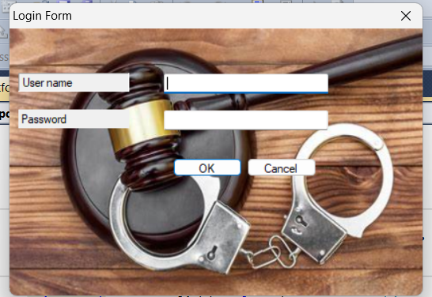

**6.2.3 LOGIN FORM (LOGIN CREDENTIALS)**

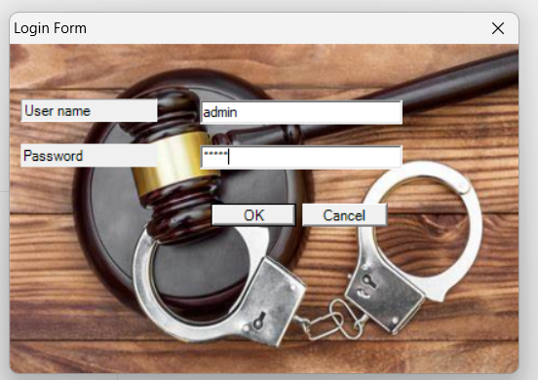

**6.2.4 LOGIN FORM (LOGIN SUCCESSFUL)**

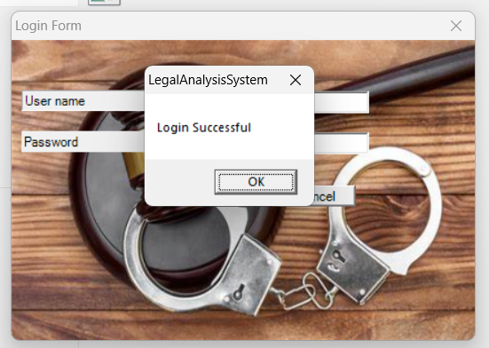

**6.2.5 LOGIN FORM (INVALID LOGIN INFO)**

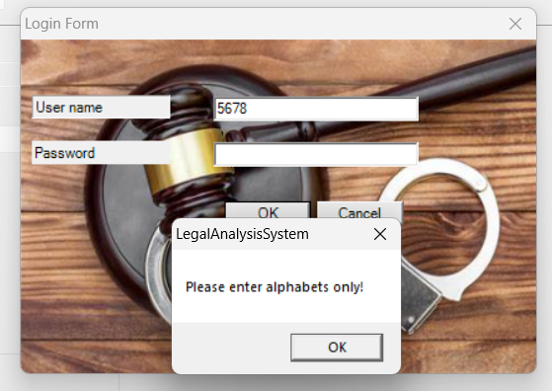

**6.2.6 LOGIN FORM(INVALID USER)**

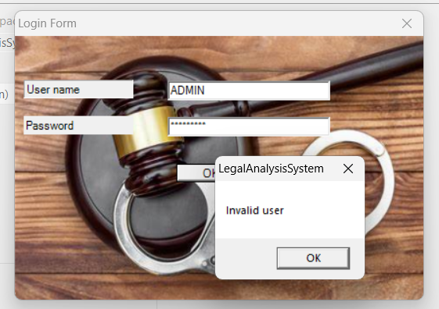

**6.2.7 MDI PARENT FORM**

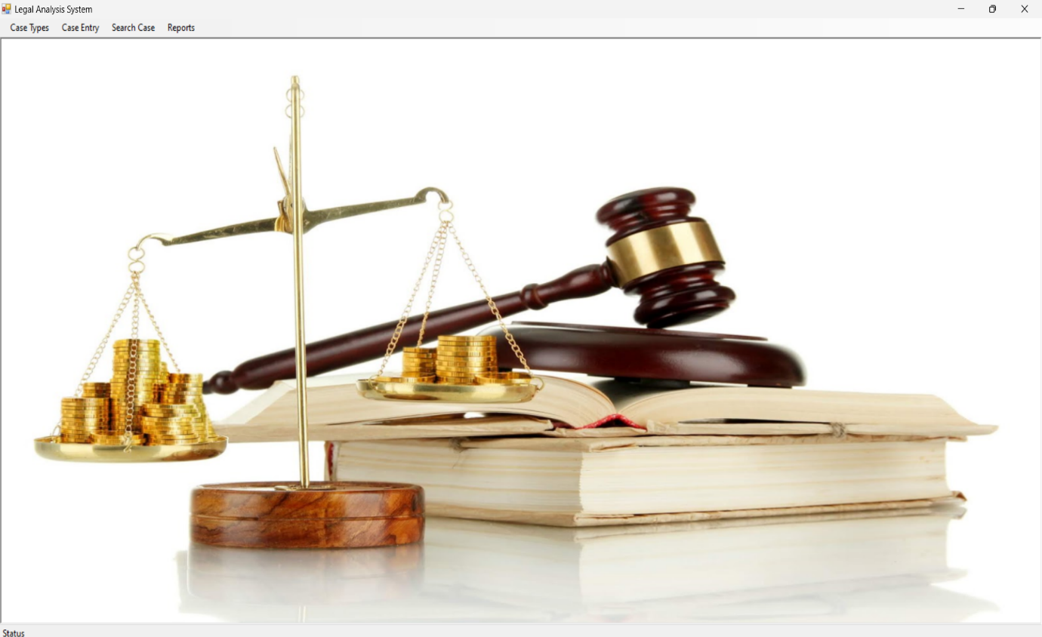

**6.2.8 CASE TYPE FORM (NEW)**

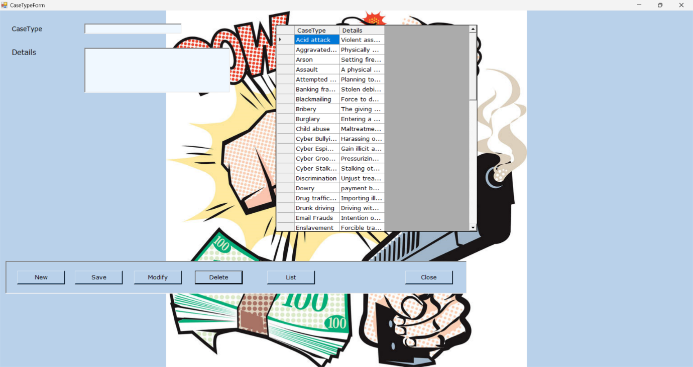

**6.2.9 CASE TYPE FORM (ENTER CASETYPE)**

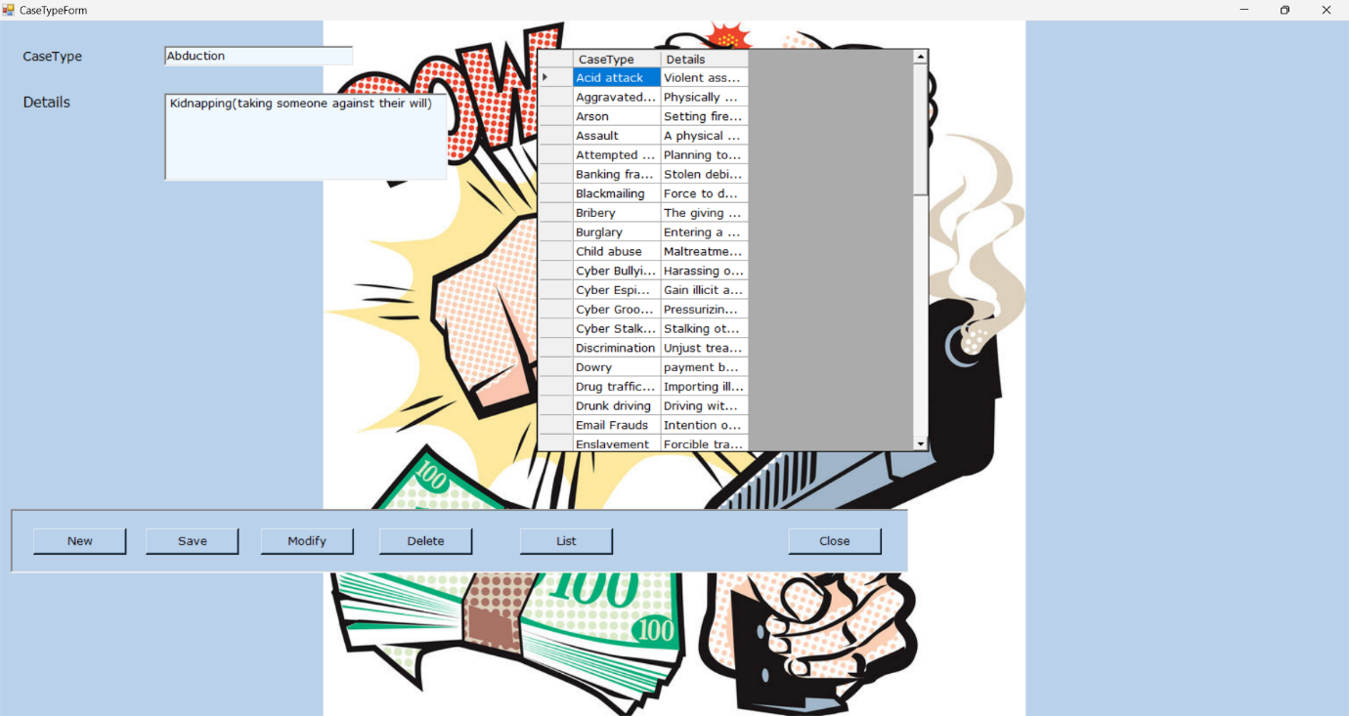

**6.2.10 CASE TYPE FORM (SAVE)**

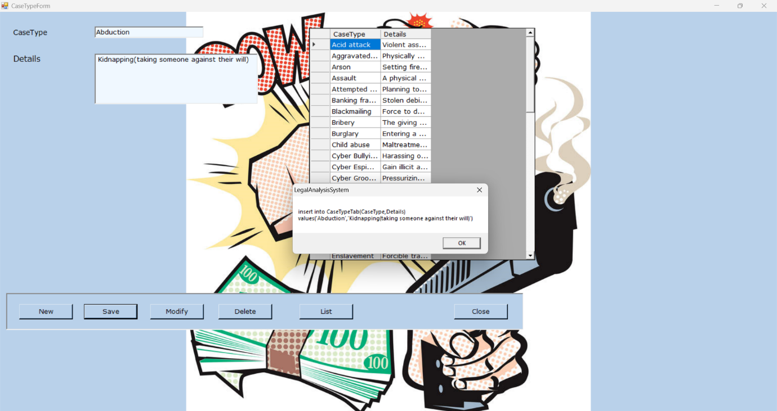

**6.2.11 CASE TYPE FORM(MODIFY)**

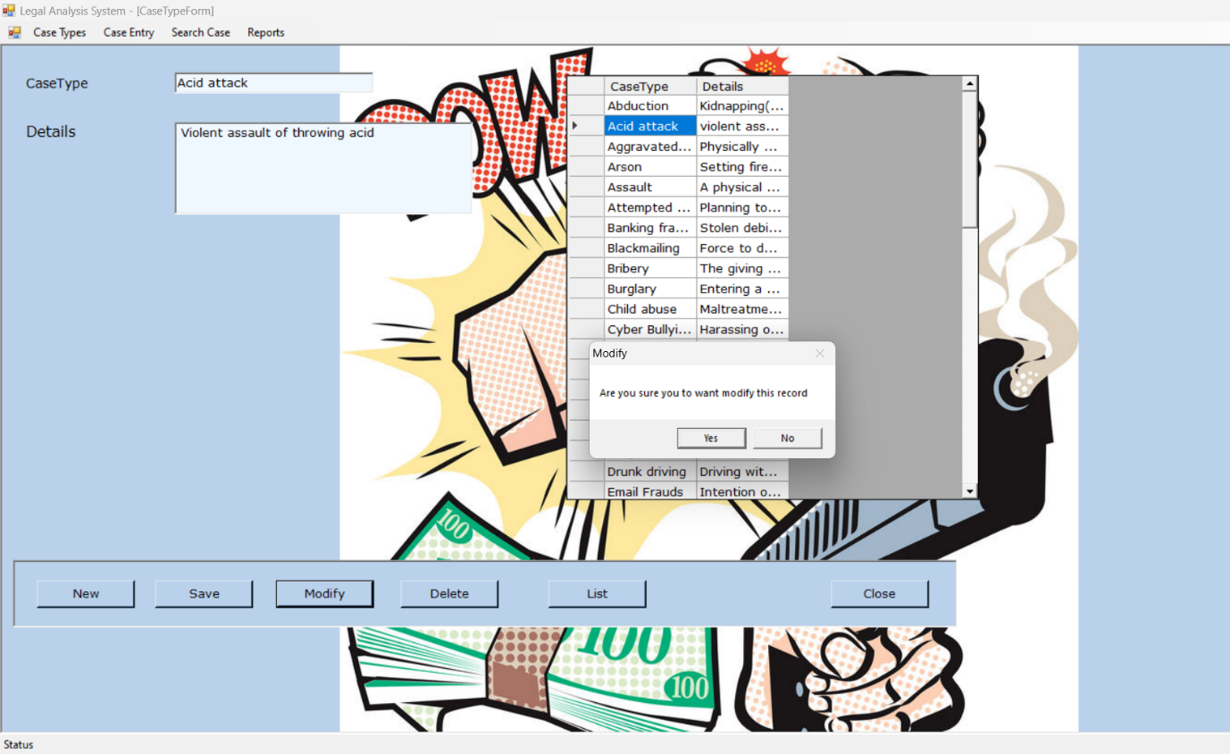

**6.2.12 CASE TYPE FORM(DELETE)**

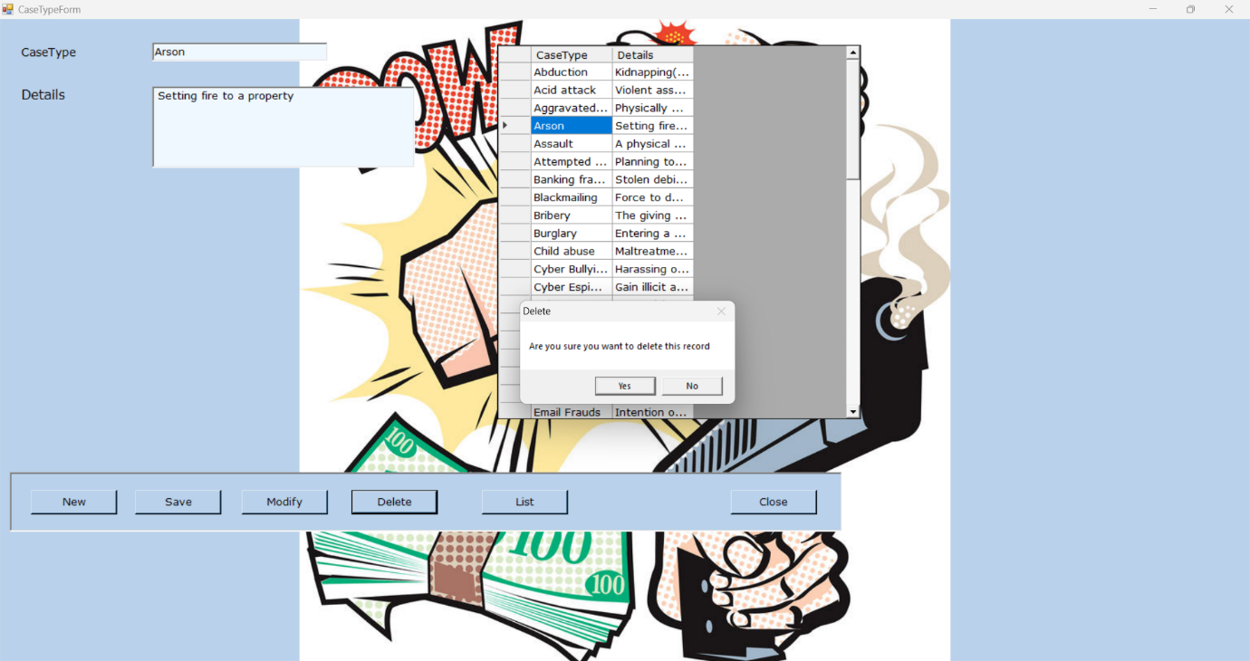

**6.2.13 CASE TYPE FORM**

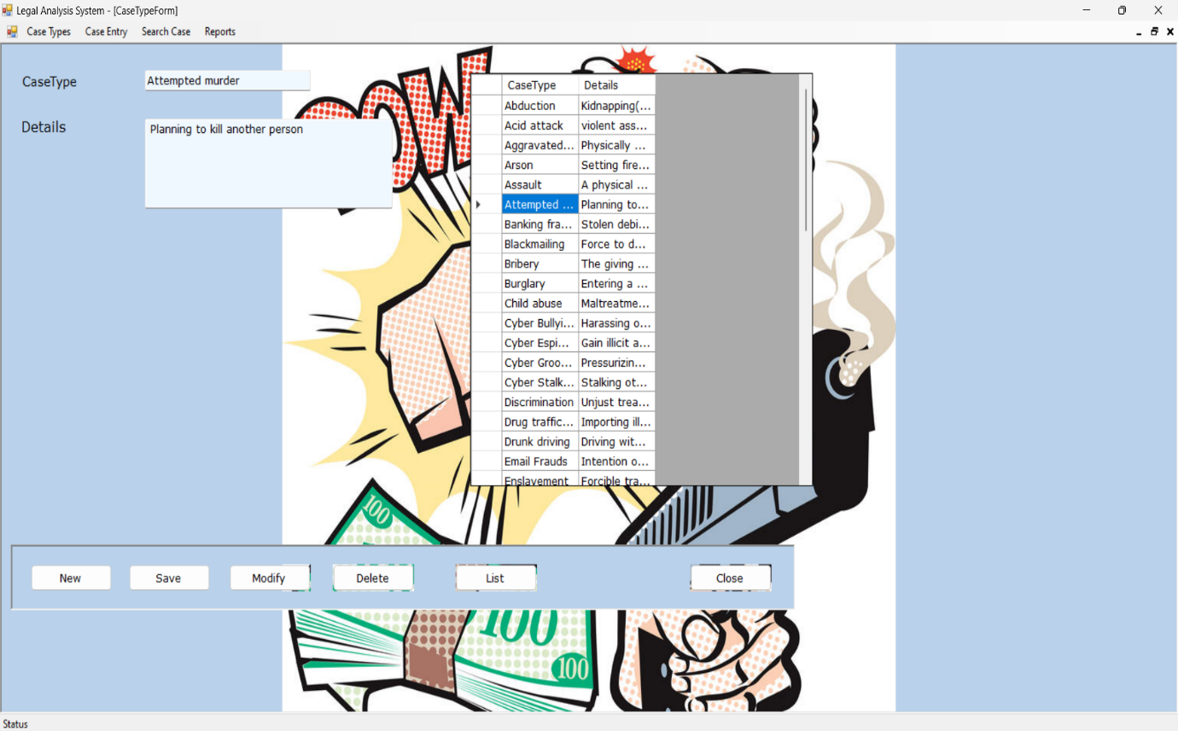

**6.2.14 CASE INFO FORM(NEW)**

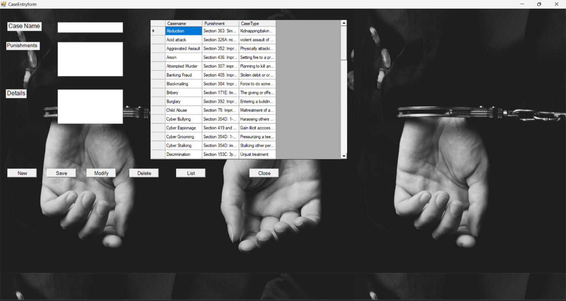

**6.2.15 CASE INFO FORM (ENTER CASENAME)**

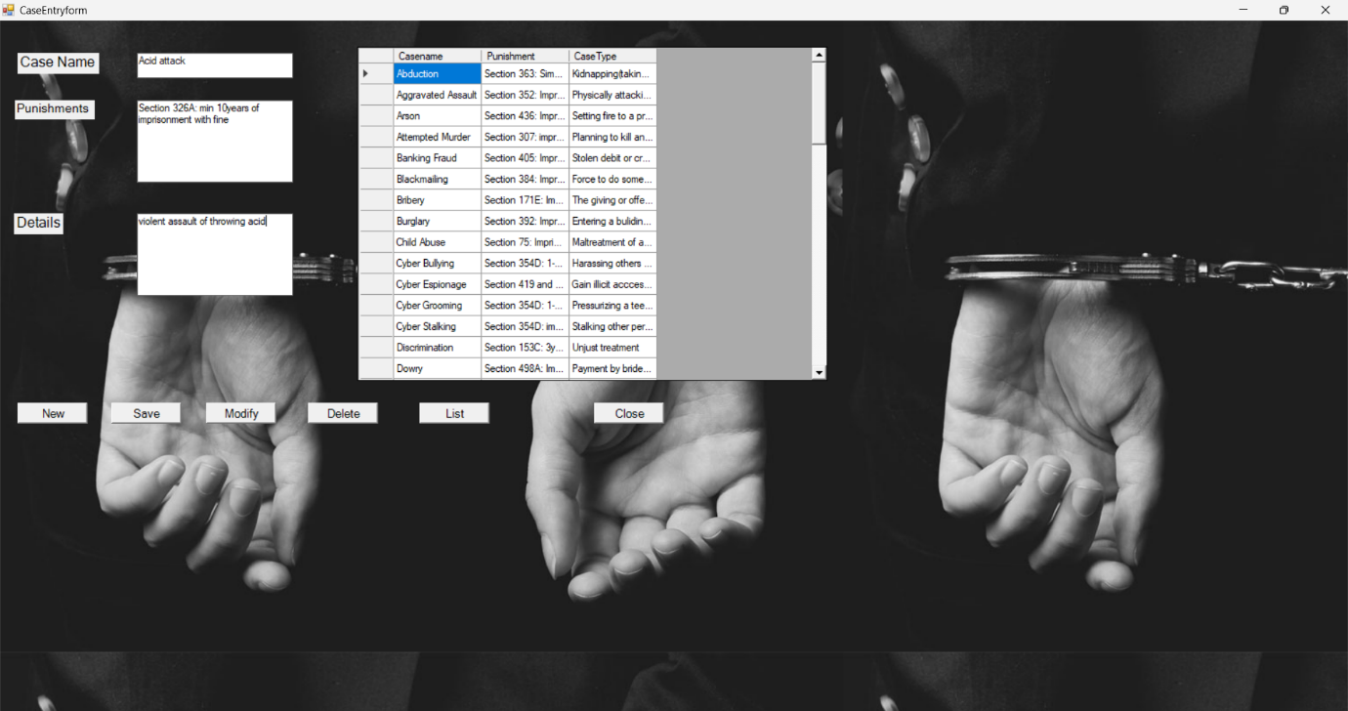

**6.2.16 CASE INFO FORM(SAVE)**

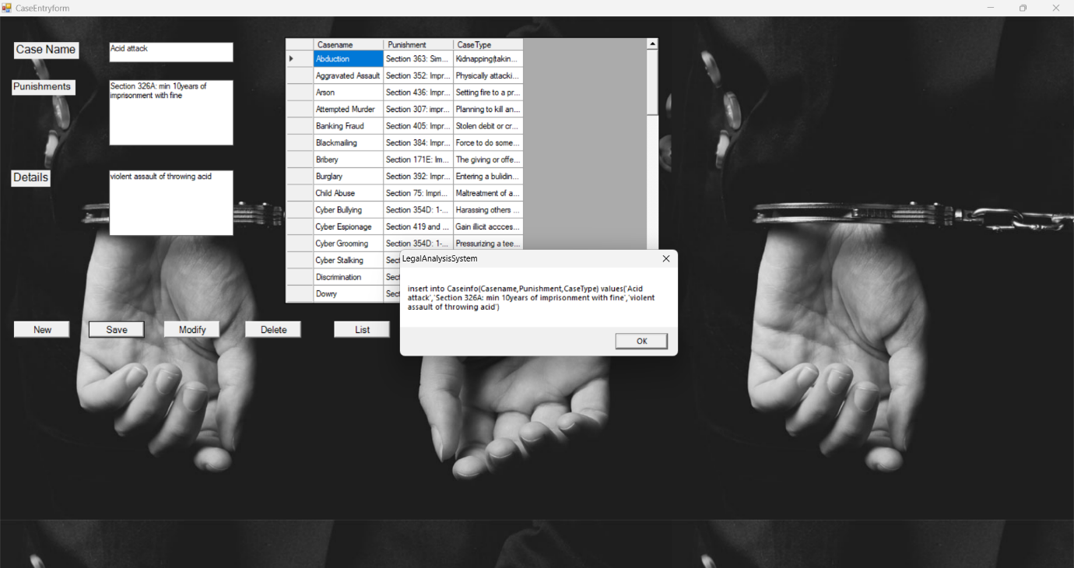

**6.2.17 CASE INFO FORM(MODIFY)**

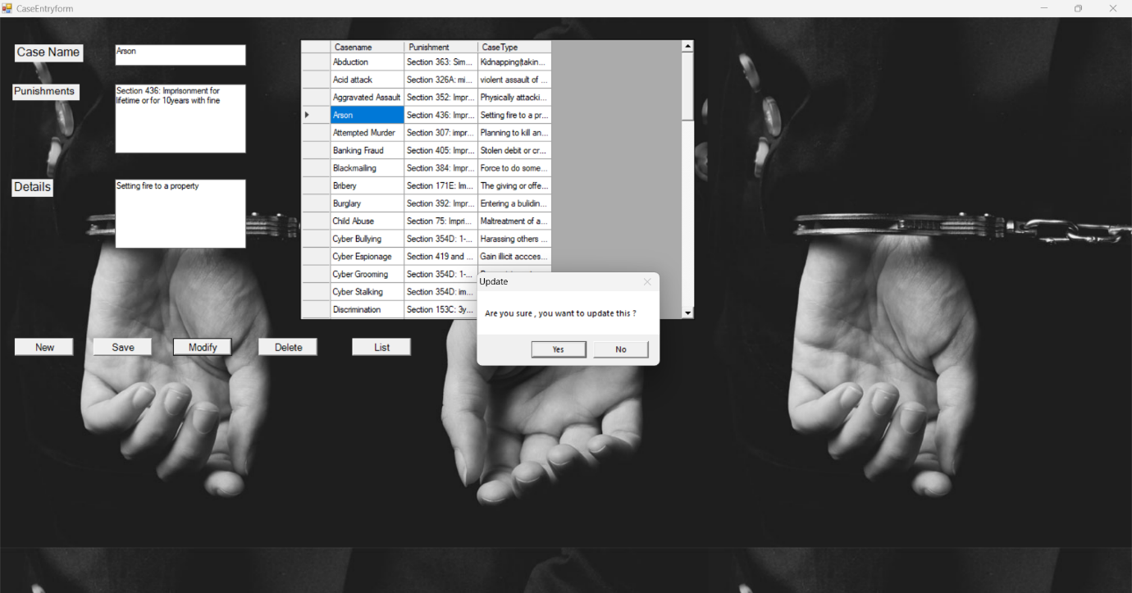

**6.2.18 CASE INFO FORM(DELETE)**

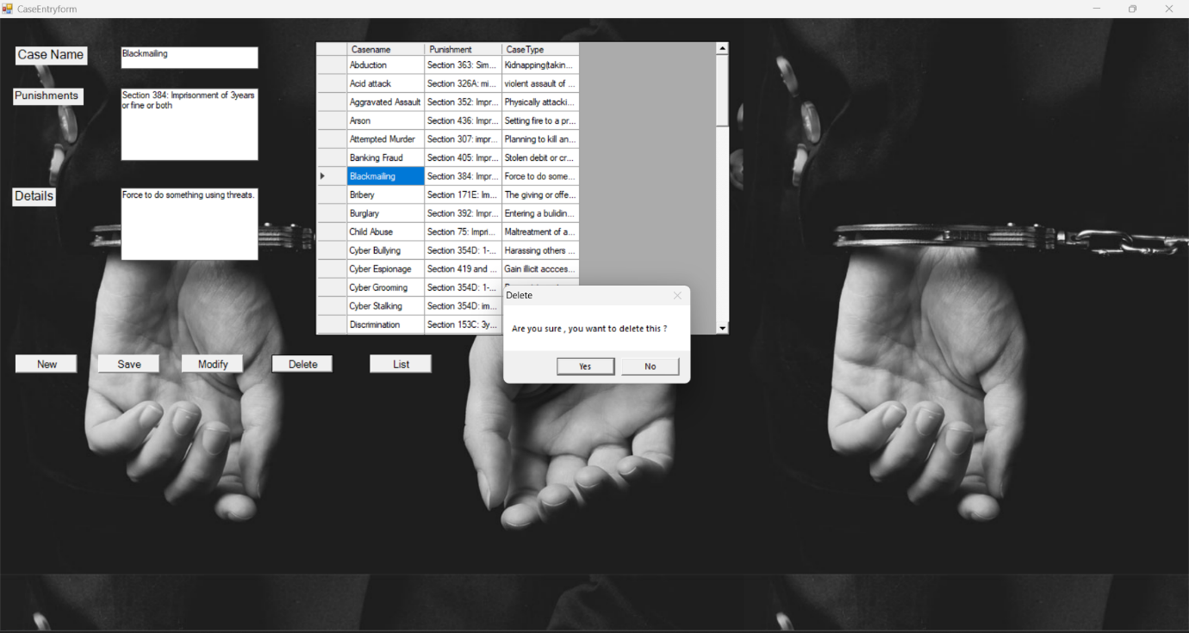

**6.2.19 SEARCH FORM**

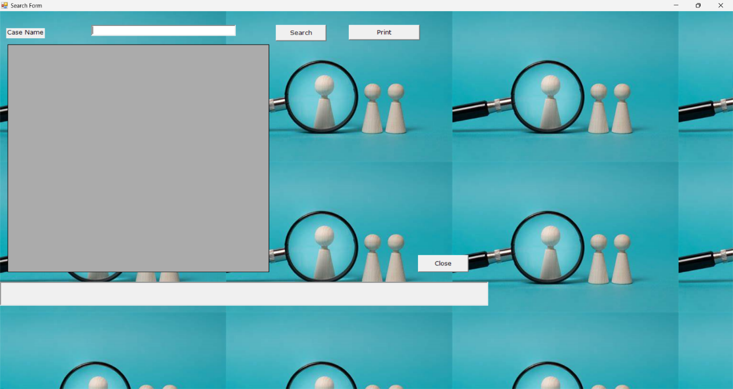

**6.2.20 SEARCH FORM(ENTER CASE NAME)**

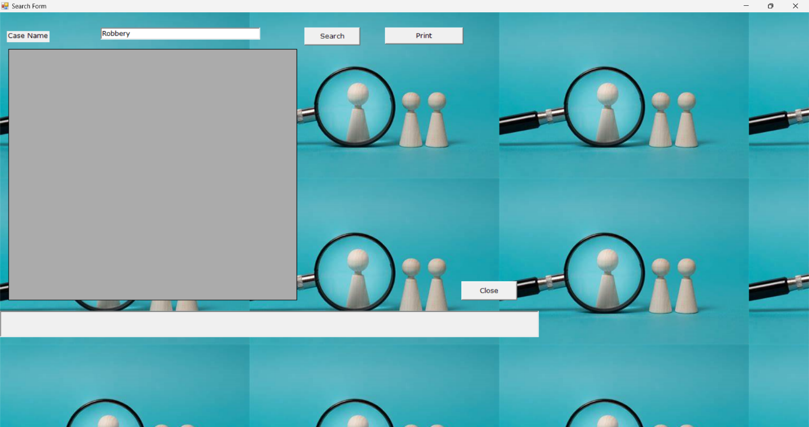

**6.2.21 SEARCH FORM(SEARCH)**

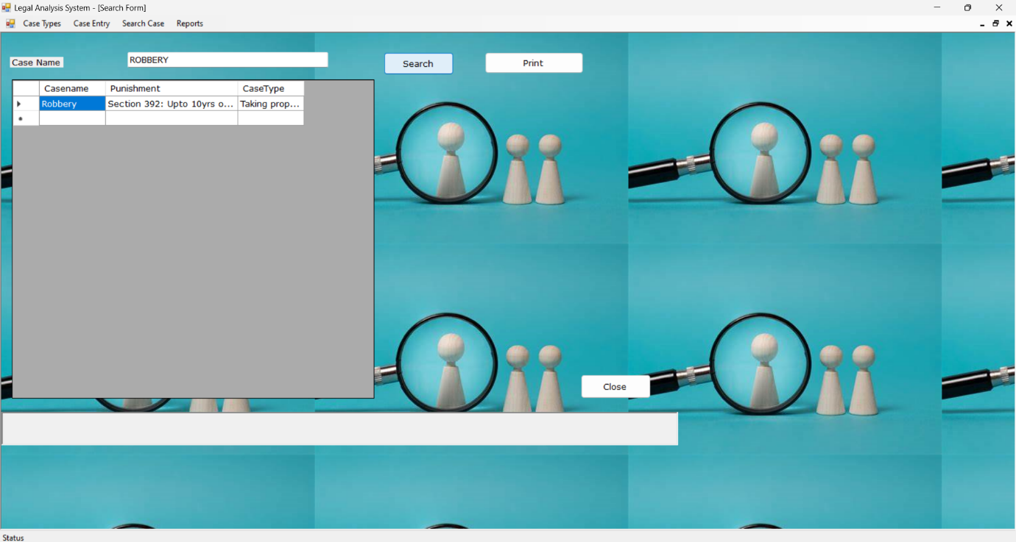

**6.2.22 SEARCH FORM(PRINT)**

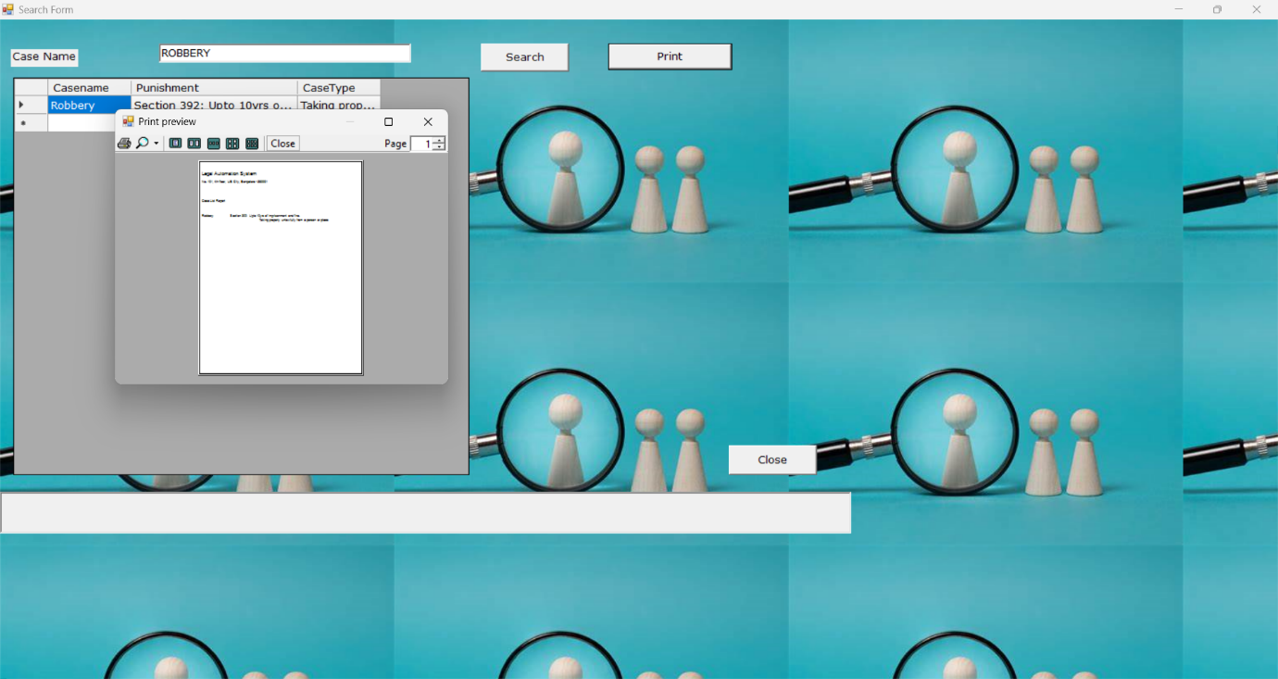

**6.2.23 REPORT**

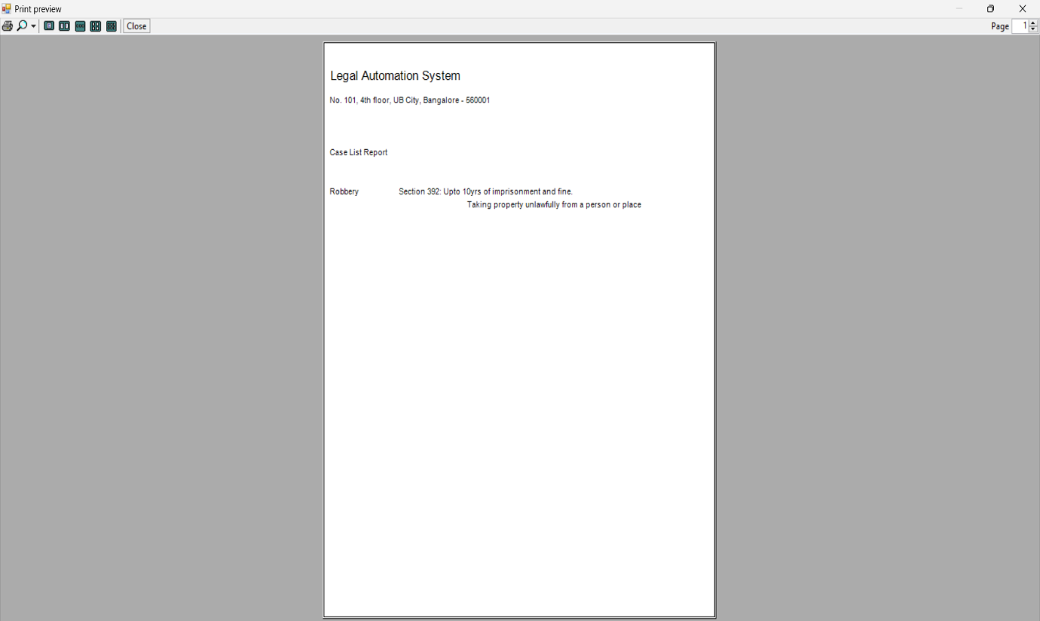

**6.2.24 REPORT FORM**

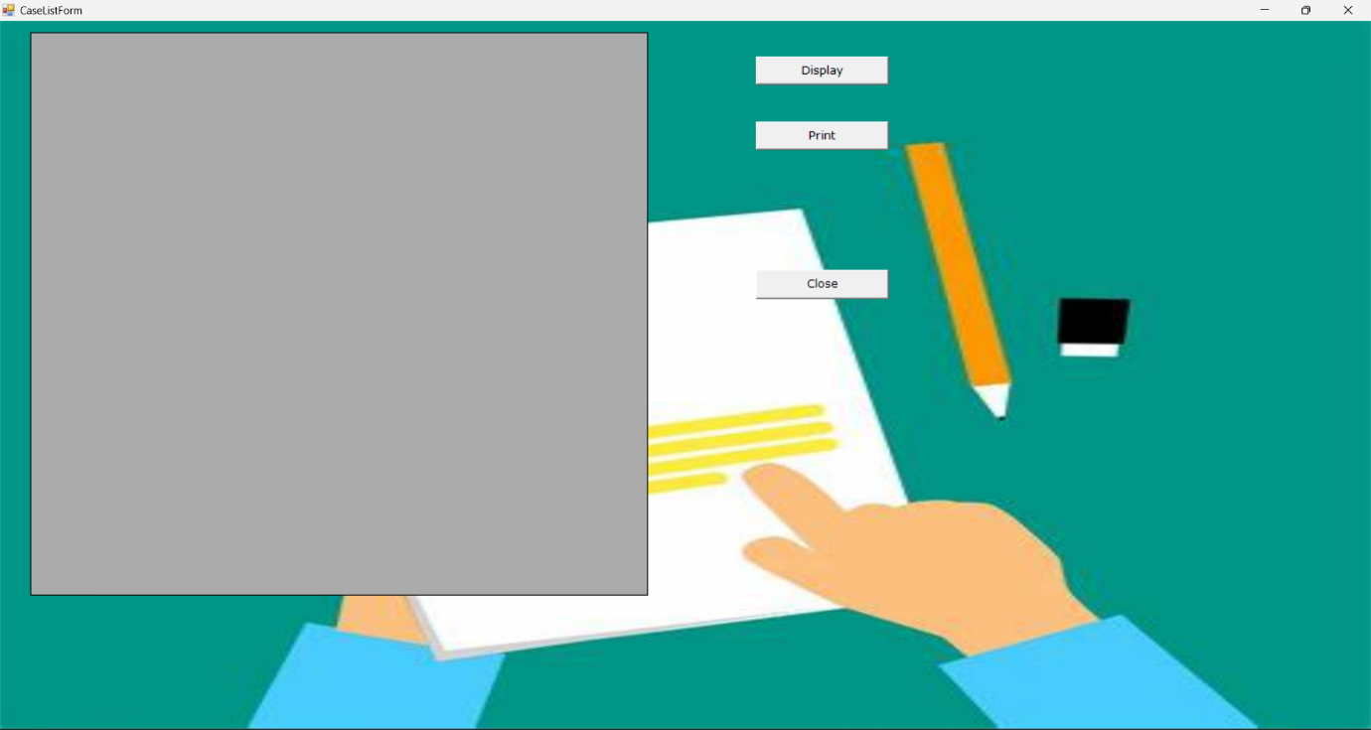

**6.2.25 REPORT FORM(DISPLAY)**

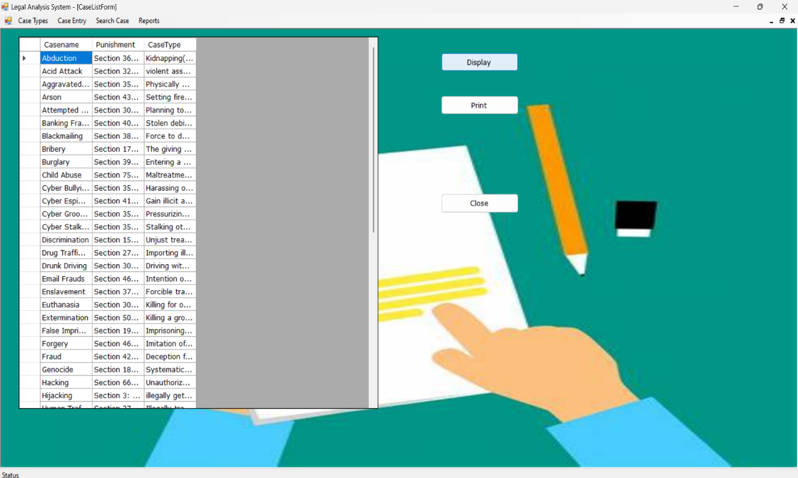

**6.2.26 REPORT FORM(PRINT)**

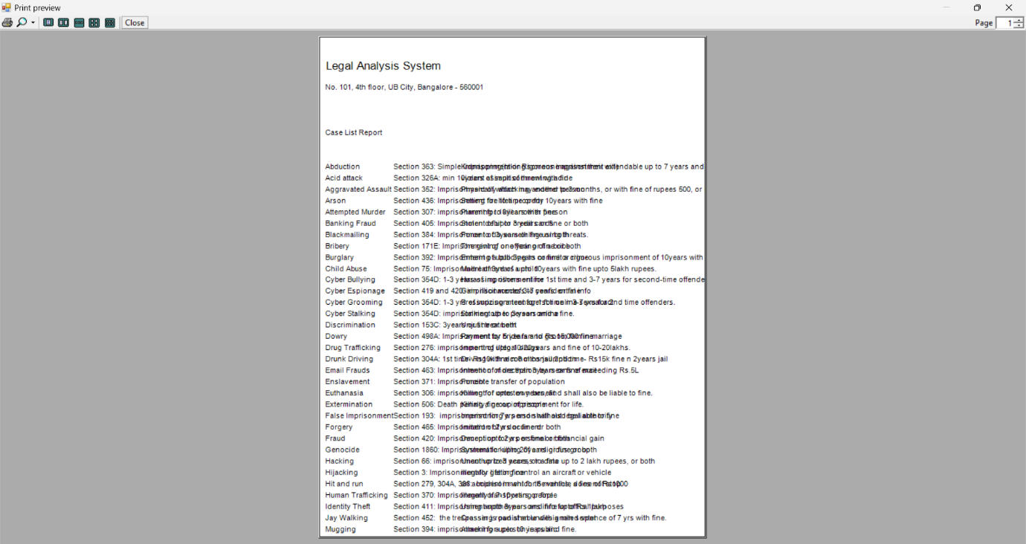

**CHAPTER 7**

**CONCLUSION**

**7.1 CONCLUSION**

The project is developed as “**LEGAL ANALYSIS SYSTEM**” developed in “VB.net” as front end and “MS SQL Server” as back end.

The user of this software has the option to learn about the penalties that must be meted out to every criminal. The user becomes aware of the types of crimes that require different punishments. Scalability is a design goal for this software. The software was created in a modular fashion. Both valid and invalid data have been used to test the system's modules. Each module operates properly. As a result, the developed system has achieved all of its goals and can take the place of the current systems.

The organization is completely satisfied with how well the project turned out. The constraints are successfully met and overcome, and the system is created as planned during the design phase. The project provides useful guidance for creating a complete application that meets user needs.

The system is versatile and adaptable. This software's user-friendly interface makes it easy for the user to use without experiencing any difficulties. Errors have been significantly reduced by validation checks. To upgrade the software, provisions have been made. With live data, the application has been tested, and the outcome has been positive. As a result, the software has demonstrated its effectiveness.

**7.2 FUTURE SCOPE**

Future software development has a lot of room for growth. The world of computer-related fields is dynamic and constantly evolving. The day after tomorrow, the popular technology will be obsolete. The system may be refined in order to maintain abstracts of technical advancements. As a result, it remains open. Nothing can be resolved in just one action. It is the reality that nothing in this world is eternal. So this project also has some potential for advancements in the rapidly growing and evergreen IT sector. Change will always occur. "Crime Management and Reporting System" was a project that was successfully designed, developed, and tested. Because the system and architecture are compatible, adding new modules won't be too difficult. This module can be expanded further to make this system a complete one because it has its own distinctive properties.

**CHAPTER 8**

**BIBLIOGRAPHY**

**ONLINE REFERENCES**

1. Sakib Mahmud, Musfika Nuha, Abdus Sattar “Crime Rate Prediction Using Machine Learning and Data Mining” – 202 2
2. N Kanimozhi, N V Keerthana, G S Pavithra, G Ranjitha, S Yuvarani “Crime Type and Occurrence Prediction using Machine Learning Algorithm” - 2021
3. Pratibha Kumari, Akanksha Gahalot, Uprant, Suraina Dhiman, Lokesh Chouhan “Crime Prediction and Analysis” – 2020
4. Annappa Nagaratha “Cybercrime Regulation Through Laws and Strategies: A Glimpse into the Indian Experience” - 2020
5. Peiris M.D.P.T , Shaminda M.B.D, Senarathne H.K, Dr.Gayana Fernando “Crime Prediction and Analysis System” – 2020
6. Tomas Ucol Ganiron Jr., John Stephen Chen, Ronalyn Dela Cruz, Jeromme G. Pelacio “Development of an Online Crime Management and Reporting System” – 2019
7. Pankaj Kushwaha, Kiran Kunwar, Archna Verma, Simili Shetty, Sampada Watane “Crime Prediction System” – 2019
8. Alvin Chesaro “A Law Enforcement Information Management System”- 2018
9. Omkar Vaidya, Sayak Mitra, Raj Kumbhar, Suraj Chavan, Rohini Patil “Crime Rate Prediction Using Data Clustering Algorithms” - 2018
10. Sunil Yadav, Meet Timbadia, Ajit Yadav, Rohit Vishwakarma, Nikhilesh Yadav “Crime Pattern Detection, Analysis and Prediction” – 2017

**TEXTBOOK**

1. Ashwini S. Diwakar “Software Engineering” by Skyward Publications